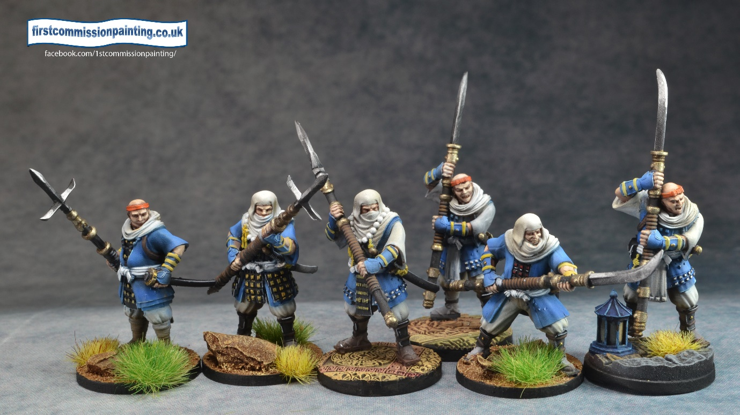
Legions - Army Lists

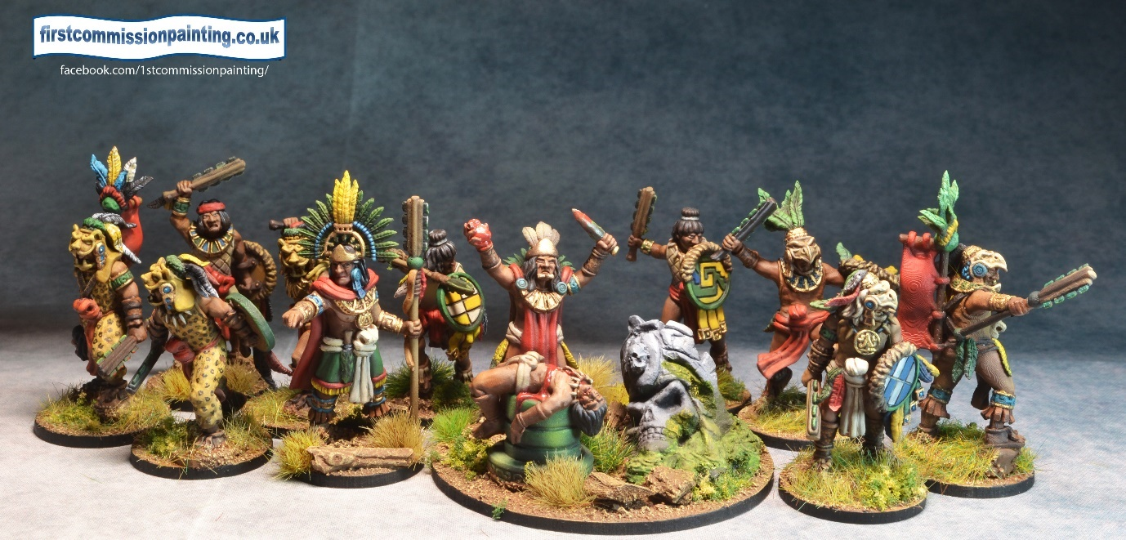

Draft Copyright Firstcommissionpainting.co.uk
How to use the army lists
The lists are designed to be used with 400 point armies and with the core rule that 200 points must come from the army choices listed in red. These represent the core troops. After choosing your core 200 you may choose any of the remaining troops in the list up to the number in brackets which indicates the maximum of any unit which can be present on the battlefield at any point in time. For every 2 points over the limit Fractions rounded up, (up to a maximum of 405 points) 1 Vp is given to the opponent at the start eg 5 extra points gives 3 VP to your opponent
There are usually 2 or 3 list options each with their own advantages in terms of troop types or special rules. For each army you need to ensure you are complying with any limitations to access these advantages.
All armies must be led by a general or equivalent. Some armies have named leaders who must be the army general. The general must be identified to the opponent before the start of the game.
Units in blue are units that a Magician is able to summon with the Summons spell – one successful summons is allowed per Magician per turn.
Disclaimer – where historical or geographic accuracy clash with coolness there is only one winner.

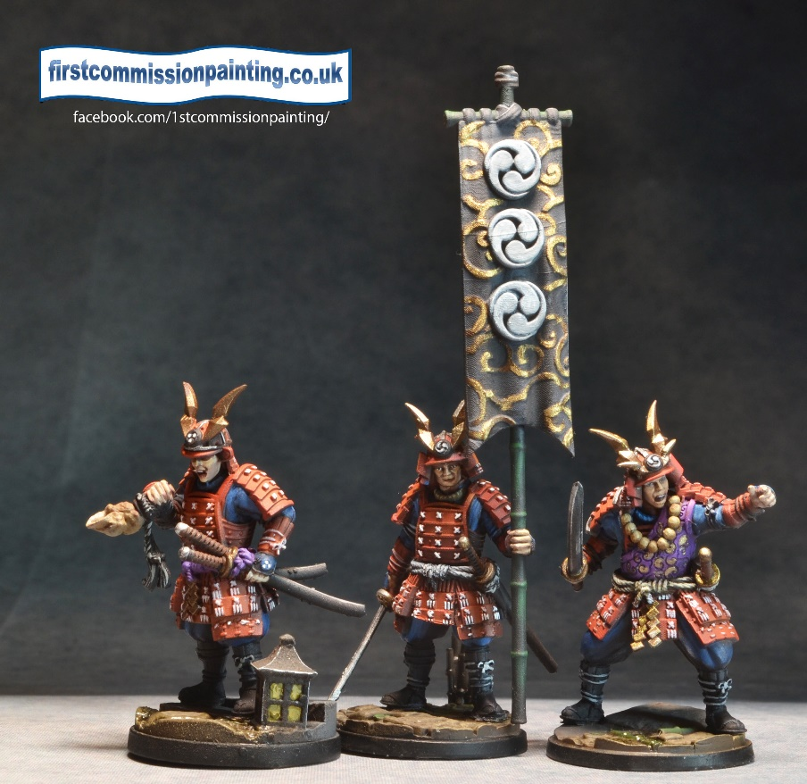
Lists
- Africana
- Amerindian
- Ancient Greece
- Araby
- Cathay
- Celtic
- Egyptian
- Horse Lords
- Japanese
- Medieval Europe
- Northmen
- Persian Empire
- Roman
- Slavonia
- Warriors of the Sun

Africana
African armies are Sub Saharan including units as far apart as Zulus to Masai with Central African thrown in for good measure! It is clearly at the fantastical end of the scale…
The Africana standard army led by the Warrior chief benefits from the Bullets to water army rule. This allows native hero and troop units to reroll any of their defence dice against missile fire whilst not in cover. It requires at least one witch doctor unit to be on the battlefield.
A Zulu army require at least 9 units of Azande/Zulu. This army gains the Deep strike flank army rule for up to 6 units of troops with the advance attribute.
A Ritual warfare Army must contain 12 units of Tribal warriors/Tribal Warriors Bow in any combination and be led by a Tribal Chief. Armies then gain Pygmies and Lion men with the advance attribute. It may ignore the limits on heroes. It has the Will of the Gods Army rule which is that when any enemy unit dies this army may draw an activation card and discard another card of any type.
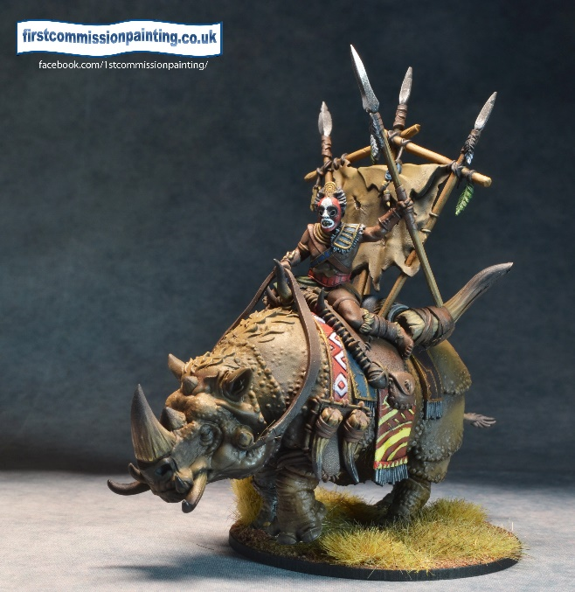
Africana Terrain (2) | card | max #
open |  | 1
scrub | 1-2 | 4
impassable hill | 4-5 | 3
woods | 6-7 | 3
jungle | 8-9 | 3
village |  | 1
gulley |  | 1
river |  | 1
thorn bush | 3 | 2
rocky | 10 | 2

Amerindian
An army which covers all of the Native American cultures of North America is ridiculous but here it is. There are elements from many peoples across the whole continent but a better treatment is limited by the lack of any ranges of pre-colombian miniatures and I did not want firearms in the army.
Great Nation Army – led by a Warchief this army benefits from the Count Coup Army Rule which allows Amerindian armies to draw and then discard a card of any type when it kills an enemy unit ie draw an activation card then discard an objective card or vice versa. It may field any units up to stated limits.
Woodland shock army – led by a Warchief this army must include a minimum of 9 Iroquois shock troops who gain Brace 1 and Support. Additionally Bears, Adlets and Wendigo become Summon 3. The Army may not use Plains mounted, Apaches or Thunder Eagle. It gains the Move like ghosts army rule which allows heroes and troops to gain hidden if they end the turn in woods or jungle and not adjacent to an enemy
Western army – led by a War chief this army must contain minimums of 6 Plains Mounted and 3 Apache (who gain advance). It may not use a Giant, Adlets, Wendigo, Giant Serpent or Witches. Heroes gain Command 2 and summons of Mountain Lions, Coyotes and Buffalo become Summons 3. It also has the Forwards army skill which allows all troop units, heroes, banners and General to deploy up to 5 hexes in from their base edge instead of the normal 3 hexes.
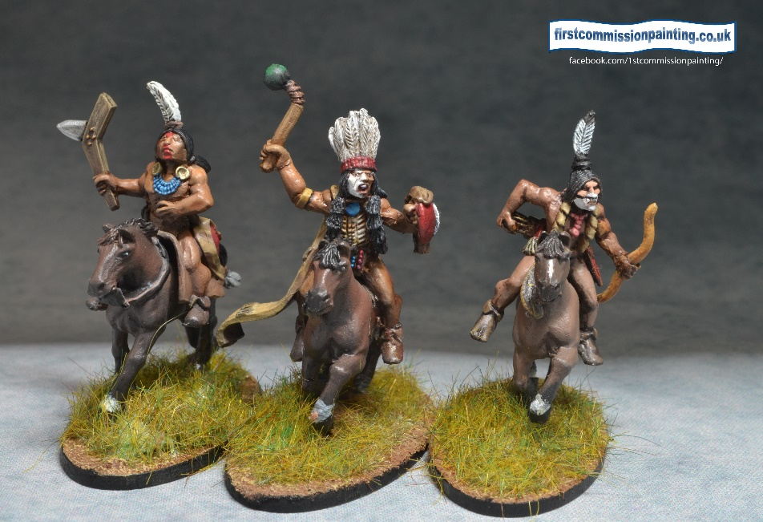
Amerindian Terrain (2) | card | max #
Eastern
woods | 1-3 | 4
village | 6-7 | 2
fields | 8-9 | 2
stream | 10 | 1
hills | 4-5 | 3
lake or river |  | 1
open |  | 1
Western
village | 10 | 1
scrub | 1-3 | 4
cactus fields | 9 | 2
hills | 4-5 | 4
rocks / boulders | 6-7 | 3
gulley |  | 2
steep hill | 8 | 3
impassable hill |  | 2
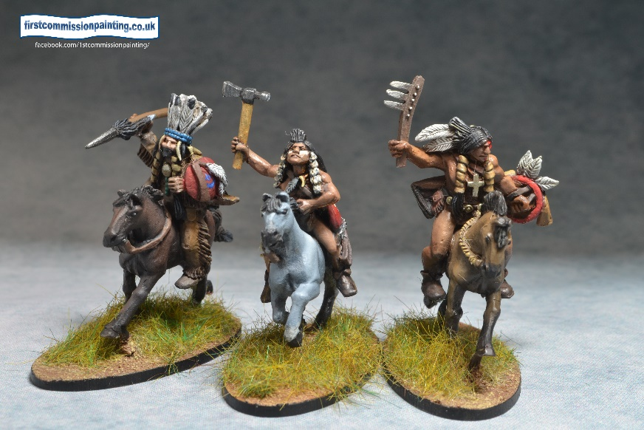
Ancient Greek
The Ancient Greek lists represent an amalgam of myth and reality across roughly 1000 years of history from the Bronze Age to the Alexandrian Successors. They will be familiar to most readers and there are 3 lists to choose from.
A Classical Greek army benefits from the Prophecy army skill which allows you to draw 12 cards (or back up to 12 cards) at the start of each turn and then discard 2. Generic general lists can use any units on the list but may not use any more than 3 Spartan, Helot, Phalanx or Companion cavalry units, nor any elephants. They must be led by a General.
Alexander the Great armies benefit from the Forwards army skill which allows all troop units, captains, banners and Alexander to deploy up to 5 hexes in from their base edge instead of the normal 3 hexes. They cannot use any Spartan, Helot, Theban or Homeric Warrior units and only 1 named Greek hero (not Leonidas). It must contain a minimum of 6 Phalanx and 3 Companion cavalry units and Alexander.
A Leonidas army benefits from the Steadfast army rule which makes all troop units Steadfast and gain Brace 1 if they do not already have it. Leonidas lists must have a minimum of 6 Spartan units and 3 Helot units plus Leonidas. They may not contain Phalanx, Companions, Alexander or Elephants.
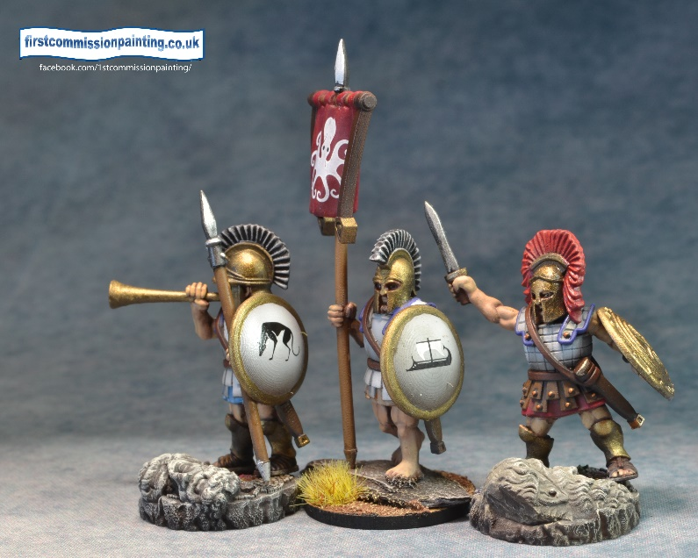
Greek (3) | card | max #
ruins | 9 | 2
hill | 1-3 | 5
steep hill | 9 | 2
woods | 8 | 2
scrub (olive/vineyard) | 4-5 | 4
stream | 10 | 1
rocky | 6-7 | 3
open |  | 1

Araby
This represents armies of the Arabic world from the earliest period through to the period of Aladdin and the 40 thieves including the famous Sheherazadic era.
The Standard Araby army is led by a Sheik and has the Desert Mirage Army rule. At the start of each turn before the first activation the Araby player declares one unit, or group of 3 same name adjacent units with Advance, to have the Hidden special rule. It must be a different unit each turn.
The Evil Vizier army is led by a Vizier and may not contain Palace Guards, Mamelukes, armoured elephants or Stone throwers and all ‘Warrior’ troops are Advance(-). On the positive side it may ignore maximums on Assassins, mages and summoned creatures other than elementals who are limited to 2. It gains the Magic in the air army rule allowing spell rerolls of 1 or 2
The Religious army is led by a mounted Sheik. It cannot summon creatures, has no palace guard, mamelukes, elephants or stone throwers but may deploy troops up to 5 hexes in from base line, all troops gain the No retreat attribute and there are no maximums on Ghazis and camel riders. It gains the Inspired by death army rule whereby whenever a hero or troop unit dies, an inspire counter is placed on a unit in line of sight.
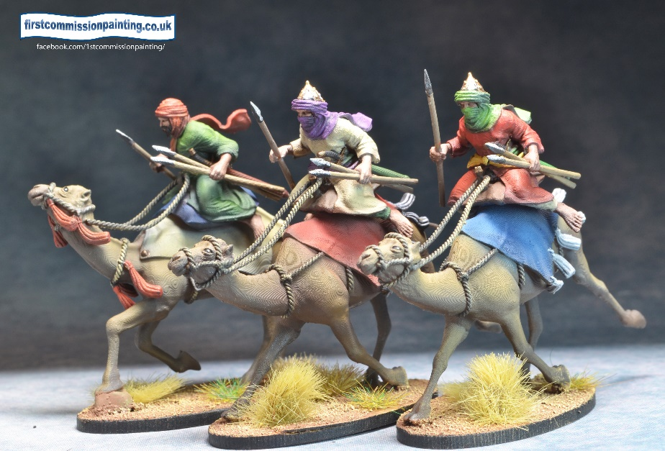
Araby Terrain (4) | card | max #
open |  | 2
dune | 1-3 | 4
scrub | 4-6 | 4
oasis (lake & woods) | 10 | 1
village | 7 | 1
wadi | 8 | 2
soft sand | 9 | 3
steep hill | 10 | 3

Cathay
Cathay represents the whole of ancient China geographically plus the Indochina area throughout ancient history..
Imperial Chinese army has access to all troops in the list and benefits from Disciplined army rule which allows the army to immediately activate a second ‘Imperial’ unit once per turn
Ancestral Army may ignore restrictions on Chariots, Cataphracts and Terracotta army. It may not use Rocketeers or Elephants. It benefits from the mandate of heaven army rule which allows it to draw 2 objective cards at the start of each turn instead of one, then discard one.
A Southern army may use up to 3 Elephants, 6 Rocketeers and 6 Pirates but no Chariots, Cataphracts, Steppe nomads or Terracotta army. It has the Eager army rule which gives all troops the ability to reroll any or all of their attack dice on their first attack of the game if it would qualify as a charge
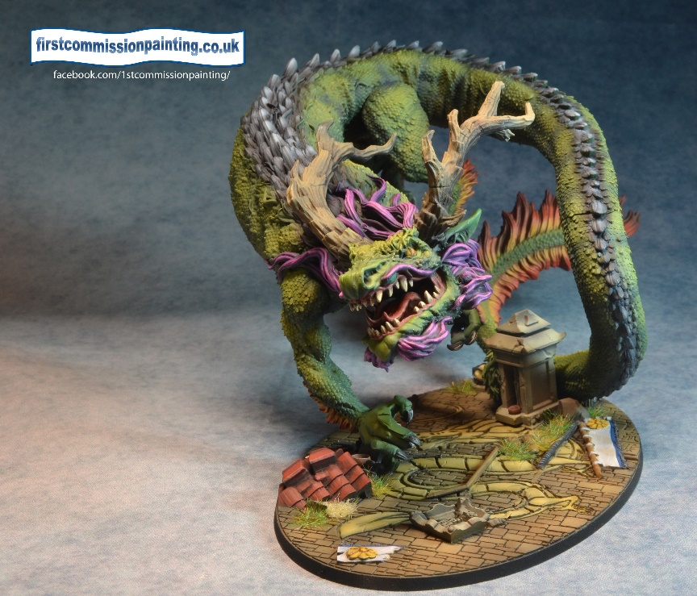
Cathay Terrain (3) | card | max #
village | 4-5 | 3
shrine |  | 1
paddy fields | 1-3 | 4
river |  | 1
stream | 10 | 1
steep hill | 6 | 3
impassable hill | 7 | 3
bamboo grove | 8 | 3
woods | 9 | 2
orchard |  | 1

Celtic Army
This represents all the Celtic Iron Age across Europe from the hard charging Galatians to the British chariot formations with the Standard army representing the classic Gallic Wars armies of Vercingetorix.
The Celtic army has the Eager army rule which gives all ‘Celtic’ troops the ability to reroll any or all of their attack dice on their first attack if it would qualify as a charge. All units are available to this army and it must be led by a chief.
The Britons army may field up to 6 chariots and 2 druids. It may use up to 3 forest trolls and 3 possessed. The army has a terrain number of 1 instead of 3. No Cavalry are available. When summoning Druids may always reroll one die for free. It also has the Magic in the air army rule allowing spell rerolls of 1 or 2.
Galatians Army has no limit on Gaesati and may have up to 3 Scythed chariots. It may not have Dryads, Forest Trolls or a Druid. It also has the Inspired by death army rule whereby whenever a hero or troop unit dies an inspire counter is placed on a single unit in line of sight.
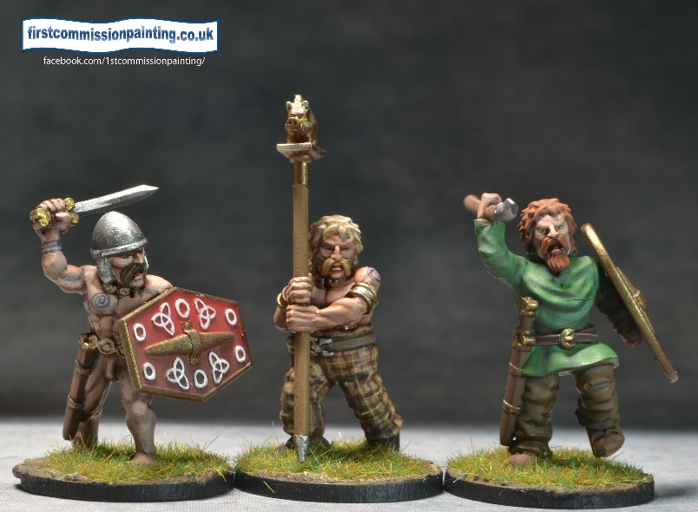
Celtic Terrain (3) | Card | bax #
woods | 1-4 | 5
village | 10 | 1
marsh | 10 | 2
hill | 5-6 | 3
fields / ditches | 7 | 2
fog | 8-9 | 3
shrine |  | 1
open |  | 2

Egyptian
Egyptian armies are probably the tightest geographically and loosest chronologically. To maintain some level of historic relevance there are fewer fantasy elements included in this list than there might have been.
New Kingdom army is led by a Pharoah in a chariot and must have a minimum of 6 light chariot units. They gain the Deep Strike Flank army rule for 6 units of troops with the advance attribute. May not use Greek mercenaries, Libyans or Scouts
Saitic Army led by a Pharoah mounted and must contain 6 units of Greek Mercenaries gains the Professional army rule which allows Mercenary Greek to activate using Advance(+), Libyan Javelin and Scouts gain Advance attribute. May not use Sherden, Sea Peoples or more than 3 chariot units.
Old Kingdom Army led by a Pharoah on foot has Desert Mirage Army rule. At the start of each turn before the first activation the Egyptian player declares one unit or group of 3 same name adjacent units with the Advance rule to have the Hidden special rule. It must be a different unit each turn. Additionally Mummies, Constructs and Giant Snake riders gain Advance attribute. May not use Greek Mercenaries, Sea Peoples or Scouts.
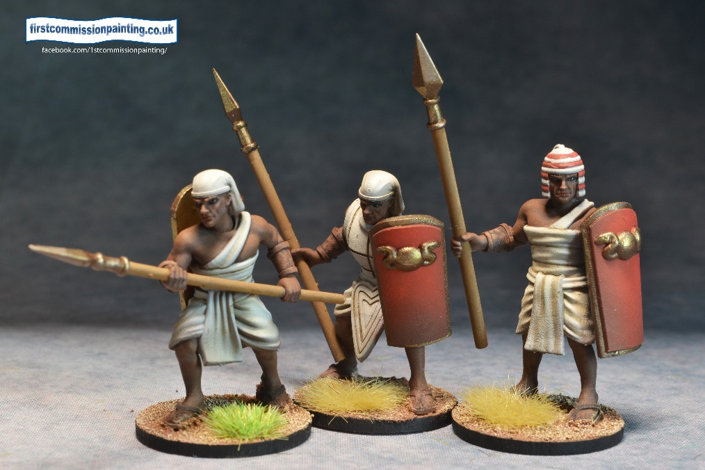
Egyptian Terrain (2) | card | bax #
ruins | 1-2 | 3
village | 9 | 1
river |  | 1
fields / fences | 7 | 2
wadi | 8 | 2
soft sand | 3-4 | 3
dune | 5-6 | 3
steep hill | 10 | 2
open |  | 2

Horse Lords
This army is a composite of the many steppe nomad armies from the Scythians, through the Huns to the Mongols and all points in between. The main difference in the lists is the change from a traditional mainly light cavalry army towards the more Chinese influenced Eastern and the more Western armies incorporating cataphracts and elephants.
Steppe Army led by mounted general must have a minimum of 9 Steppe nomads. Steppe Nomads gain Advance attribute rather than Advance(-). The army has the Deep strike Flank army rule for up to 6 units of troops with Advance attribute (see Attributes). It may not use Chariots, Cataphracts, Dragon, Cannon or Elephants.
The Eastern Khanate Army is led by a Mounted General and has the Endless Horde army rule whereby any troop unit killed by the enemy returns at the start of the next turn on the owning player’s table edge. Cataphracts and Elephants are not allowed. Up to 6 Chariots may be used
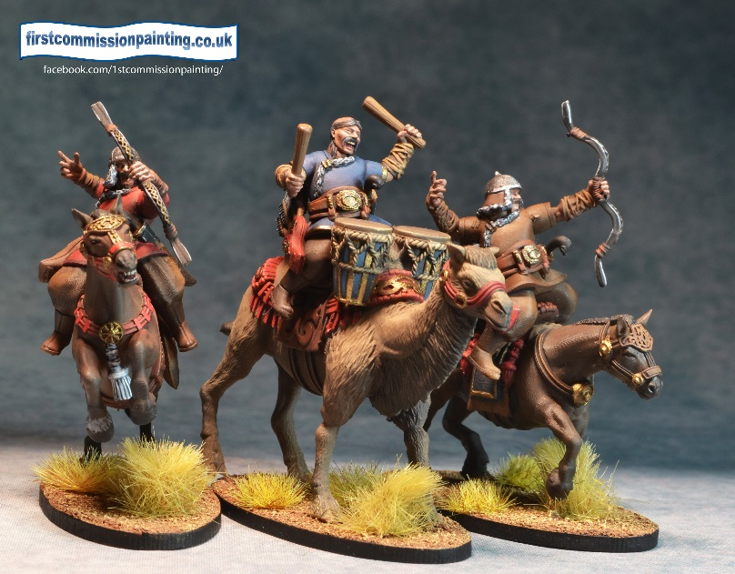
The Cataphract army led by a mounted General and has the Forwards army skill which allows all troop units, Captains, Banners and General to deploy up to 5 hexes in from their base edge instead of the normal 3 hexes. The limit on Cataphracts is raised to 6 units but no Chariots, Dragon or Medusa may be used.
Horse lords Terrain (5) | card | max #
open |  | 3
encampment | 8-9 | 2
hill | 1-3 | 5
steep hill | 10 | 2
gulley | 10 | 2
dune | 6-7 | 3
scrub | 4-5 | 4
oasis |  | 1

Japanese
This represents a relatively short period of Japanese history from around 1400 to 1600 and is basically the ‘Samurai period’ with all the associated warrior Monks, Ninjas and increasing amounts of Ashigaru infantry. The Ashigaru musket unit being the only firearm in the game.
Samurai army – where the list contains more Samurai troop units than any other troop units combined, the army benefits from the Honour army rule which gives attacking Samurai units an extra attack die when attacking units of greater points value.
Ashigaru army – where the army contains more Ashigaru troop units than other troop units combined the army gains the Professional army rule which allows Ashigaru to activate (Advance+). The army may only use Samurai and Ashigaru troops and no Acolytes.
Rebels army – where the army contains more non Samurai and non Ashigaru troops combined, the army gains the Forwards army rule allowing all non Samurai/Ashigaru troops to deploy 5 hexes in from the base edge. It also gains a free Acolyte.
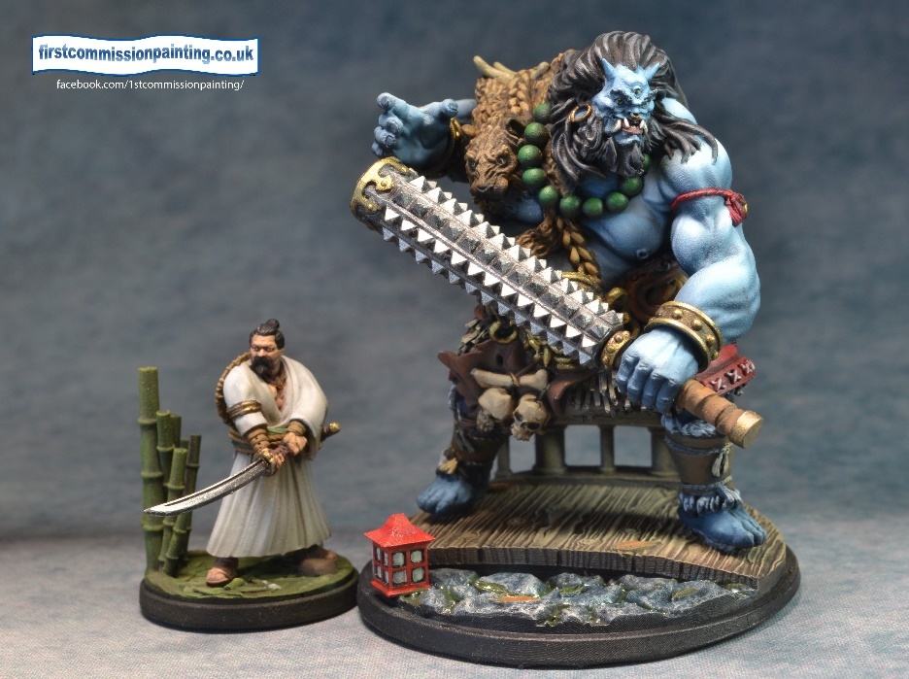
Japanese Terrain (1)
 | card | max #
village | 1-2 | 2
shrine |  | 1
hill | 3 -4 | 4
orchards |  | 2
woods | 5-6 | 3
paddy field | 7-8 | 3
river / stream | 8 | 1
fields/fences/gardens | 9-10 | 3
bamboo grove | 10 | 2
open |  | 2

Medieval European
Covering three types of Medieval knight-based armies across mainly Western Europe with a bit of Arthurian mystical thrown into the mix. These armies have access to lots of knights and some light horse but also effective missile troops
Baronial armies benefit from the Feudal army rule whereby any Knights attacking troop units of less points than themselves gain one additional reroll. Baronial armies may access all troops but may not mix any Crusader army units with any Mystical army units.
Crusader armies gain the Inspired by death army rule whereby whenever a crusader army troop unit dies an inspire counter is placed on a single unit in line of sight. Crusader armies must include 3 Templar knight units and 6 Pilgrim units as a minimum. They may not include Mystical army units (see below) nor reivers or brigands.
Mystical armies must include the Green Knight and Lady of the Lake. They cannot include Templars, Trebuchet, Reivers or Brigands. It may include up to 5 Hero knights and has the Magic in the air army rule allowing spell rerolls of 1 or 2.
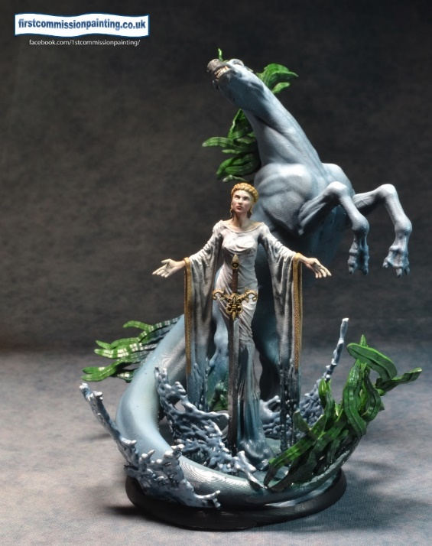
.
Medieval Terrain (4) | card | max #
village | 7 | 2
ruins | 8 | 2
orchard |  | 1
woods | 5-6 | 3
marsh | 9 | 2
fields | 1-2 | 4
stream | 10 | 1
lake |  | 1
hills | 3-4 | 4
open |  | 2

Norse Army
Norse here is a catch all for Norse, Danes, Swedes and any other Northern warrior societies. Any European Dark Age type figures will serve here for troops. It can be a very hard hitting army in any of it’s three variants.
The Great Army – default army. This army is led by a Warchief or Jarl and benefits from the Flexible strategy army skill. For each enemy unit killed you may draw a plot card and then throw one away. This army can use any units up to the maximums listed.
Raiding Party – led by a Hero and must contain at least 3 units of Reavers and 3 of Hunters who all gain Advance attribute. May also take up to 3 heroes including the leader. They cannot use Trolls, Giants or Mammoths. They gain the Deep Strike Flank army rule for 6 units of troops with the advance attribute (see attributes).
The Witch Army – an army led by the Seidmann shaman may ignore the requirements to take core troops and may take any number of non core (except only 1 Giant). This army has the Magic in the Air army rule allowing rerolls of 1 or 2 on any spell
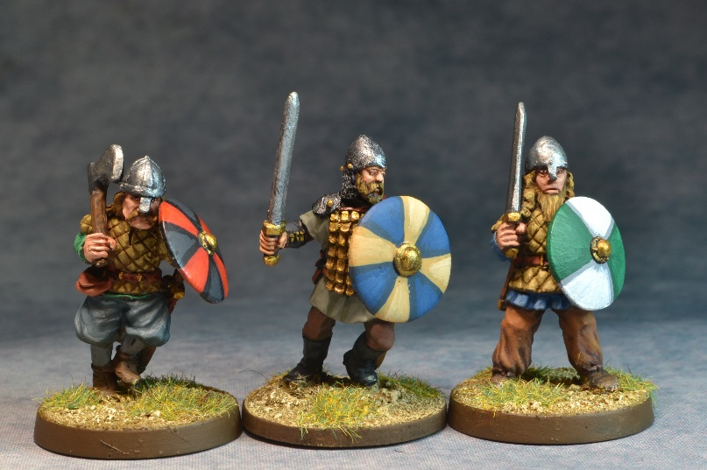
Northmen Terrain (5) | card | max #
river | 10 | 1
lake |  | 1
village | 9 | 1
forests | 1-3 | 3
hills | 4-5 | 3
steep hills | 9 | 2
rocky / boulders | 6-7 | 3
open |  | 1
snow drift | 8 | 2

Persian
Probably the most historically and geographically tight of all the armies covering the classical period of Cyrus to Darius III but also with a nod to the later Sassanids with the inclusion of cataphracts.
King of Kings This army is led by a General in a Chariot and benefits from the Flexible strategy army skill. For each enemy unit killed you may draw a plot card and then throw one away. This army can use any units up to the maximums listed.

End of Empire army is led by a General in a Chariot and has the Endless Horde army rule whereby any troop unit killed by the enemy returns at the start of the next turn on the owning player’s table edge available to activate. Sparabara may not be taken but up to 6 units of Hoplites may be included.

Zarathustran mystical army led by General mounted. This army has the Magic in the Air army rule allowing rerolls of 1 or 2 on any spell. It may have Hoplites or Sparabara but not both. Must include a High Priest and at least 1 Priest
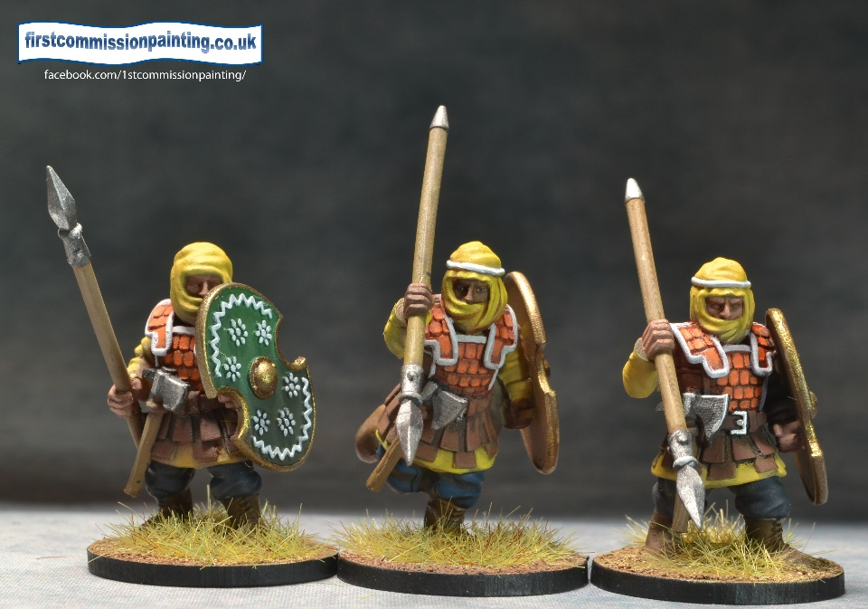
Persian Terrain (3) | card | max #
village | 7 | 2
scrub | 8 | 2
woods | 5-6 | 3
hill | 3-4 | 3
gardens | 9 | 2
steep hills | 10 | 2
fields / walls/ | 1-2 | 4
stream |  | 1
orchards |  | 2

Roman
This list covers Rome from the Republic to the end in the West in quite a generic way. Barbarians might be Goths or Gauls and there is no effort to differentiate Caesarian legionaries from Late Roman. The Eagle represents any type of iconic army symbol not just the famous Imperial Eagle.
The Republican Army – a generic army led by a General which has the Discipline Army rule which allows the army to immediately activate a second ‘Roman’ unit once per turn. The Republican army may not use Cataphracti, steppe cavalry or Elephants but may use any number of levied citizens and 2 Augurs. Augurs count as WP5 magicians.
Imperial Rome – led by a General and must include an Eagle, 6 Legionary and/or Auxiliary units. It has the same Discipline Army rules as the Republican Army but gains the advantage that it can access all listed units. All ‘Roman’ units gain Veteran.
End of Empire. Led by a Mounted General this army may use any number of barbarian Allies and/or (6) steppe cavalry. Up to 4 cataphracti may be used but no Gladiators or Elephants. No Augurs can be used but up to 2 Libitinarii may be used. It has the Flexible Strategy Army rule - For each enemy unit killed you may draw a plot card and then throw one away.
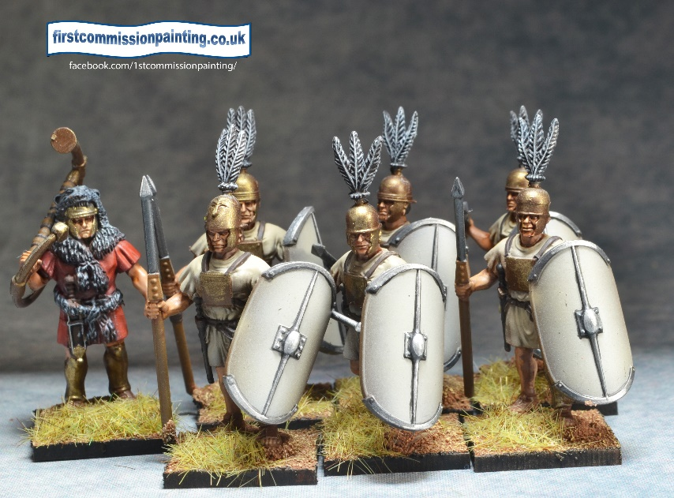
Romans Terrain (4) | card | max #
village | 8 | 2
fields / walls | 6-7 | 3
scrub (olives etc) | 1-3 | 4
hills | 4-5 | 4
hills steep | 9 | 2
stream |  | 1
ruins | 10 | 2
open |  | 2

Slavonia
‘Slavonia’ is clearly a catch all name for the various cultures of Eastern Europe from Muscovy to Transylvania and as far west as Bohemia. There is room in the list for Hussite wagons, Gothic knights, Polish Hussars and Cossacks as well as some strong mythical elements.
A Slavonian army is led by a Baron and may use all units as listed except for a Count. The Army benefits from the Forward defensive army rule which allows all Eastern Infantry to be deployed +2 hexes forward of their deployment zone as if behind Walls which make all attacks disadvantaged (does not stack) until the unit moves in any way, War Wagons count as infantry but do not gain any additional bonus beyond the +2 hex deployment gain.
The Witch Army is led by a Witch and gains the Magic in the air army rule. It may only use militia and steppe nomads but can use 6 Beastmen and one more of all units than the list maxima for all units below the Beastmen in the list except the dragon and giant
The Count Army is led by the Count and ignores all minimums on cavalry. It has the Eager army rule which gives all horsemen troops the ability to reroll any or all of their attack dice on their first attack if it would qualify as a charge. It may use only Militia infantry and only a Witch, Wolfpacks, Werewolves and Vampyrs of creatures listed below the Bear in the list.
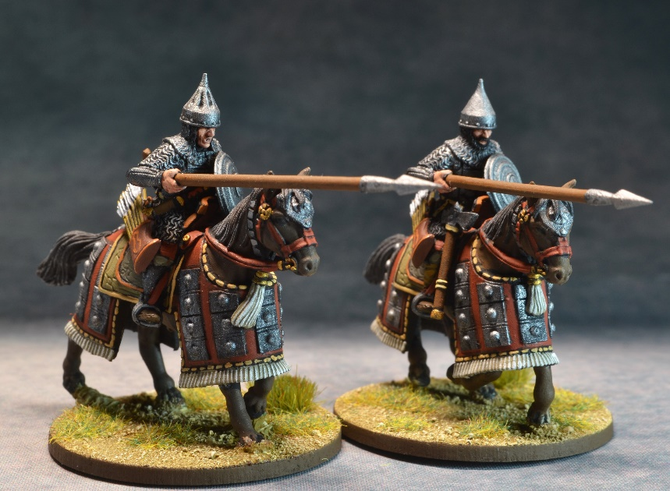
Slavonia terrain | card | max #
woods | 1-4 | 5
dense woods | 5 | 2
village | 6 | 2
fields/ walls | 7 | 2
hills | 8 | 2
gulley | 9 | 1
marsh | 10 | 1
stream | 10 | 1

Warriors of the Sun (Mesoamerican)
This list encompasses all the civilisations of central America and even adds a little bit of Inca. The Aztecs are at the front of the list as at the time of writing there are few options around to field miniature Incas. Hopefully as 3d printing progresses we will be able to separate off a purely Precolombian South American list based on the Incas with Amazonian additions.
Great King Army – must have an Army General as leader. This Army has access to all units and benefits from the Sacrifice army rule. When any enemy unit is killed this army gains a prisoner token which can be used for an exact reroll or to spend on a new plot card.
Religious Army – must be led by High priest and contain the altar and at least 1 other Shaman. This army may have up to 6 Heroes, contain at least 6 Cuachic (who gain the Advance attribute) and all troops become Fearless with No retreat It gains the Magic in the air army rule allowing spell rerolls of 1 or 2.
Coyote army – A coyote army must include 3 units of Conquistador allied infantry, 3 Mounted Conquistador, a Cannon and a unit of War dogs. It must also include the Maximum amount of Otomi mercenaries. It may not include a high priest, Altar or Jaguar / Eagle knights. It benefits from the Flexible strategy army skill for each enemy unit killed you may draw a plot card and then throw one away.
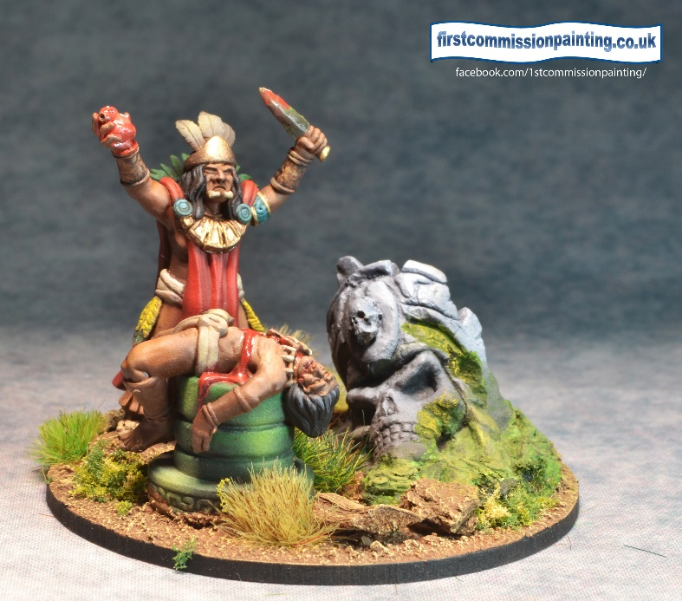
Mesoamerican (3) | Card Max #
village | 8 | 2
river |  | 1
woods | 1-3 | 4
jungle | 9 | 2
fields/walls | 4-5 | 3
marsh | 6-7 | 2
lake | 10 | 1
hill | 10 | 2
open

