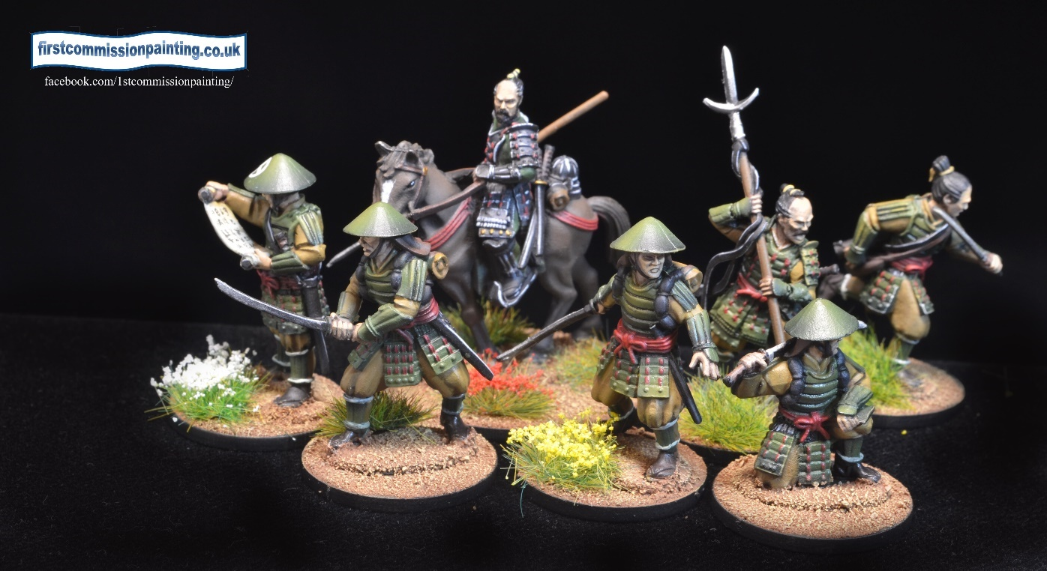

LEGIONES ANTIQUITATAS

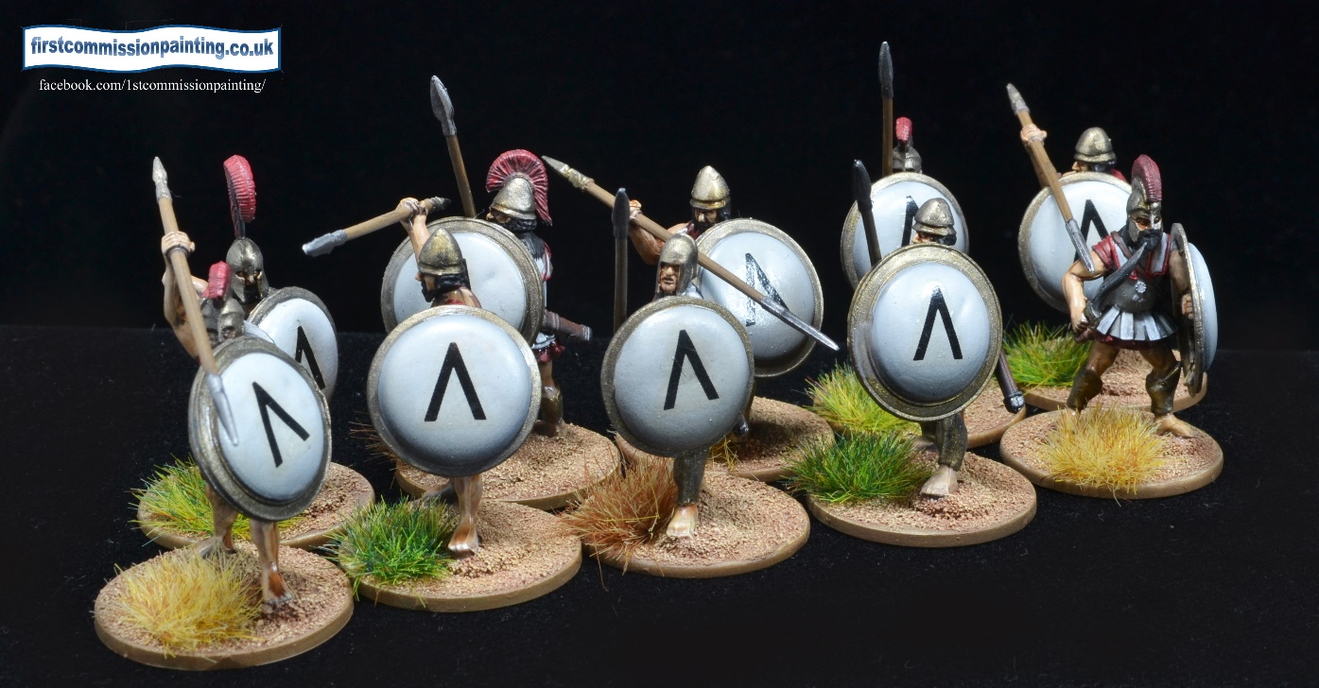

• **Contents.**

• 1.0 Introduction to the game

• 1.01 Turn Sequence

• 1.1 Activation of units

• 1.2 Activation actions

• 1.3 Activation card usage

• 2.0 Command

• 3.0 Movement

• 3.7 Special moves

• 4.0 Combat

• 5.0 Willpower

• 6.0 Magic use & spells

• 6.7 Spell Chart

• 7.0 Objectives

• 7.12 Deployment maps

• 7.2 Plot Cards

• 7.3 Tactical deck

• 8.0 Terrain chart

• 9.0 Attributes

**Genaral Introduction**

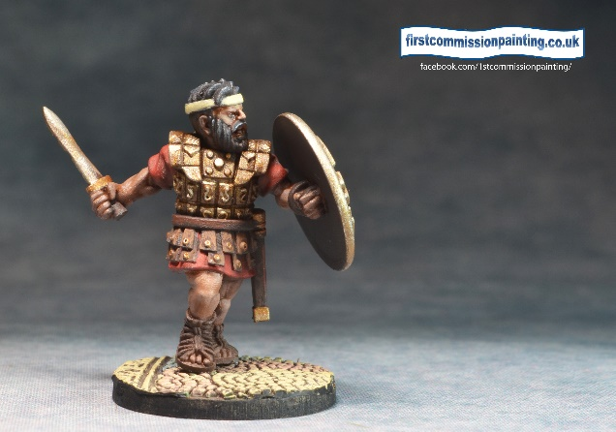The aim of these rules is to give players with collections of ancients' figures the opportunity to play an ‘ancients’ type game with fantasy elements, or indeed for those players with Fantasy armies the opportunity to play with those figures but with ancients elements. For example who wouldn’t want to use their Macedonian pikemen and peltasts alongside Hercules and a Hydra? Or your Japanese Samurai but with Yokai and Oni?

The increasing use and popularity of 3d printers is also opening up new possibilities for using impressive and dramatic new models whether they be Norse, Celtic or Aztec, which can be played with these rules.

The game has 14 lists which have ‘historical/geographical’ armies (using both terms in the very loosest sense of the words. Armies contain troop types from hundreds of years and hundreds of miles apart in the same list. This is not meant to be a simulation! This allows the player considerable latitude and the fact your army might contain a Wendigo or a Troll makes any historical concerns mute.

The game itself is played on hexes which removes all measurements and speeds play. We use 3” hexes for 28/32mm miniatures but you can use smaller or bigger as long as the number of hexes remains the same or similar. There are recommended numbers for troops per hex but the game plays exactly the same whether you use one hoplite or four on a base. Once you are comfortable with the mechanisms, a game is over in between 2 and 2 and a half hours.

In the near future lists for pure Fantasy armies will be produced which will allow you to battle Elves against Native Americans or Goblins against Romans.

**1.0 The game - introduction**

The game is played over 4 (or 5) turns and victory is decided by a combination of Kill Points (7.0.1), Objective Points dependent on the mission objectives (7.1) and Plot Points (7.2) in play. First player to 40 vp wins immediately on reaching 40. Otherwise most points at game end wins.

The battlefield is 15 x 13 hexes for 400 point games. Armies must contain 150 points of keyword troops – (these units are marked in red on army lists). An army may stray up to 405 points but your opponent starts with 1VP for every 2 points over 400 (FRU). E.g. 404 points = 2 VP, 405 points = 3 VP

15 x 13 3”hexes fits easily onto a 4’ x 3’ mat.

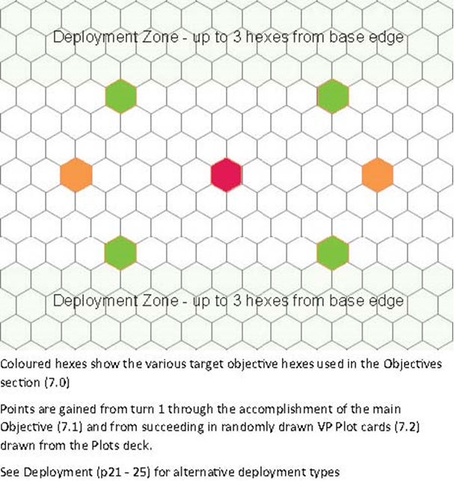

*Coloured hexes show various alternate target hexes used in the objectives although different deployments are possible see*

Units may be SMU (single “figure” units) of one Hero or one non massive Beast figure per hex otherwise they count as MMU (Multi figure units) of more than a single miniature.

eg Infantry are 3 miniatures, cavalry are 2 miniatures.

There are a very few units which occupy 2 hexes due to depth of bases eg chariots, mammoths etc These always count as MMU. Movement rules are slightly different for those units see 3.7

Gameplay is by alternately activating units with the side that wins initiative choosing whether to take first activation of a unit or passing to the opponent. If you wish you may pass your activation but passing costs an activation card and you cannot pass twice in a row. You may choose to completely stop activating units at any time but cannot restart once stopped.

If either side runs out of activations the other side may continue activating until unable to.

**Turn sequence**

**1.01 Pre-game actions**

Pick your army from your list, including Army special rule and choose any spells your magician(s) are taking allocating per magician if more than one magician.

a. Roll d6 for Home and Away team then terrain types (see army lists) and lay out terrain **7.1**

b. Roll d6 for objective **7.2** and then deployment type **7.3**

b. Both sides draw 5 cards from the Plot/Tactical deck

c. Both sides draw 10 activation cards from their deck

d. Roll d6 for Deployment order – winner may choose deployment area or to deploy first or second. Whichever he chooses the other alternative passes to the other player.

e. Deploy armies as decide in step d. Player deploying first deploys half his units (FRU), second player deploys all units then first player deploys remaining units

f. Roll for initiative in turn 1 and subsequent turns

1.1 **Player activations**

a. Play an activation card

b. Move, fight, spell, etc. See sections 3, 4 & 6. Tactical cards must be played on a unit at start of activation or at the point in time stated on card. Plot cards played as they are achieved.

**End of turn**

Conditions such as poison and burning applied.

Removal of end of turn spell effects eg blind

Play of plot cards for points

Check for objective points

*Check for Sudden death conditions – if both sides reach 30 during end turn phase the higher total wins*

Discard unwanted cards from activation hand and draw new hand up to 10

End of turn 4 only - roll a d6 and on 5-6 play a 5th turn.

**1.1 Activation of units**

At the start of each turn players receive 10 playing cards. A unit is activated by the playing of a card (or cards) which is equal to or greater than than the activation number of the unit type eg

**Heroes 3**

**Troops 5**

**Beasts 7**

You can add cards together to equal or exceed the activation number required - card colour is irrelevant. *An impossible to achieve plot card can activate any unit.*

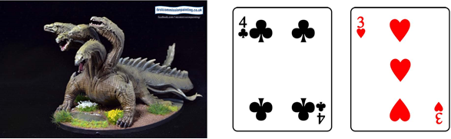



EG 1.1.1 Player X wants to activate a beast but has nothing higher than a 4 left in hand, he does have a 3 and a 4 however and as 7 is equal to the required activation number of 7 he plays them together and activates the beast. It is inefficient but allowed.

A captain with *Advance* or a Hero with *Follow me* (or other skill which allows it to activate other units) may activate troops as part of its activation on his lower value card.

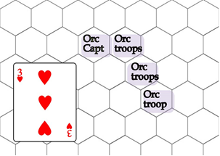

EG 1.1.2 An Orc Captain adjacent to one of 3 other Orc units – adjacent to each other and of the same type - may play a single 3+ (hero activation card number) to activate himself and the valid Orc units. He nor they can activate again this turn.



***Advance attribute*** - Up to 3 troop units with the same name ie. Hoplites which start adjacent and have the *Advance* attribute may activate as one activation.

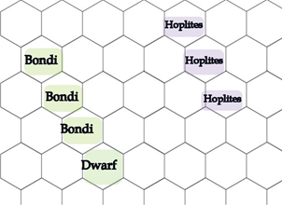

Up to 3 Troop units with the same name for example the three Hoplites, which start adjacent and have the Advance attribute may activate as one activation but must end their activation adjacent to each other and take the same actions.

The 3 Bondi may do the same but the Dwarf unit may not activate with the Bondi despite also having the Advance attribute as he has a different name ( and therefore a different profile).

**1.2 Activation Action types**

Each Activated unit may carry out 2 Actions. These may be any of

* Move

* Fight

* Command x

* Cast spell

* Card actions – specific to unit/character

* Interaction eg pick up or drop objective, drop trap etc

A unit can do these in any order but may not fight twice unless specifically allowed by its attributes. **Nor** may it move after fighting unless it has an Attribute such as *Hit and run*

Units may also occasionally trigger a different unit to do an Action outside its Activation as a card action. This is resolved within the active players turn at the moment of triggering.

**1.3 Card usage options**

RED

1 to 5 REROLL Attack dice / spell dice of the SAME number as the card or use for valid unit activations

6 to 10 any valid unit activations or reroll **all** attack / spell dice up to this number or take an extra interaction action

ROYALS ( face cards ) Reroll any number of dice on attacks / spells or to activate any unit

BLACK

1 to 5 REROLL Defence dice / WP dice of the SAME number as the card or use for valid unit activations or gain extra movement (3.5)

6 to 10 use for MOVEMENT bonus (3.5) or unit valid activations or reroll **all** defence / WP dice up to this number.

ROYALS (face cards) Reroll any number of dice for defence /WP rerolls or for movement bonus (3.5) or for unit activations

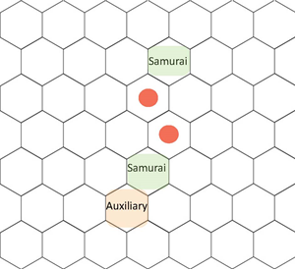

A Samurai warrior unit uses a 5 to activate (as troops) and moves (red dots) as his first action. He then attacks the adjacent Auxiliary unit with 4 attacks, requiring 4s to hit, rolling 3.3.4 and 1. He can reroll the 1 as he has the Skilled 1 Attribute and he also declares that he will play a red 2 to also reroll the other two misses at the same time achieving 3 hits in total.

The Auxiliary unit with 3 defence dice and 3 HP rolls 1,3 and 3 so will be killed. However the player has a black 1 in hand and uses it to reroll 1 dice achieving a 5. The Auxiliary unit takes 2 hits and lives

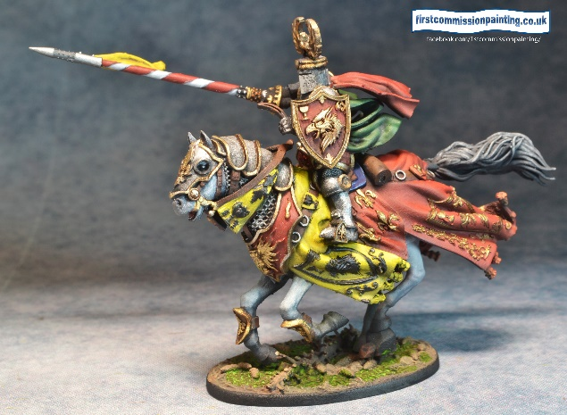

**2.0 Command**

At start of turn draw 10 cards from your deck. These cards represent your resources in several ways.

A. Winning Initiative, roll d6, highest deploys first and goes first in turn. Each turn the player with the lower roll may play one card face down to try and win initiative that round, the higher rolling player then responds in the same manner. On revealing the higher card takes initiative. IF players play the same value card then separate in the order Spades, Hearts, Diamonds, Clubs. If both sides play the same card then continue playing cards until resolution.

B. At the end of the turn you may retain or discard any number of unused cards you have then at the start of the next turn, before initiative, draw back up to 10 cards.

C. Cards are required to Activate a unit, or group of units which have the Advance Attribute or through a hero/captain activation.

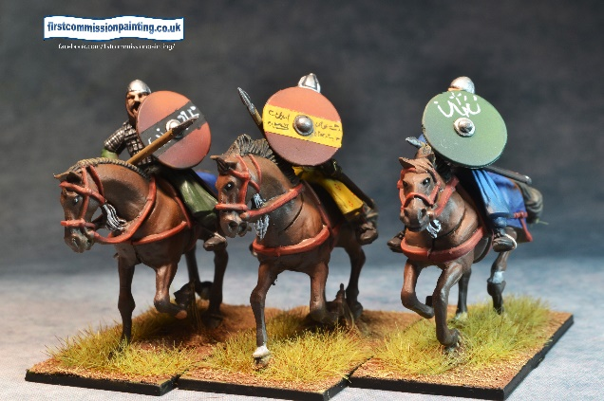D. Passing – you may discard a card to pass an activation but cannot pass two activations in a row.

**3.0 Movement**

3.1 All movement is in hexes as per the unit card represented as 2 numbers separated by a /. The number left of the / is its first activation move, the number to the right it’s **total** movement if it uses both activations to move.

EG 3.1 Standard foot movement is 3/5 which allows a first action move of 3 points of movement or a double move of 5 points of movement.

3.2 Movement can be affected by terrain (see terrain table **8.0**) and the presence of enemy units. Moving through difficult terrain will usually cost an additional movement point unless the unit has the Skirmish or Light *A*ttribute.

3.2.1 Light and skirmish – troops with the Skirmish or Light Attribute may move through most terrain as if it were open ground. Light troops may be disadvantaged by bad terrain but Skirmish are not in most cases.

**All single man hero units on foot count as skirmish but not if mounted**. See terrain chart 8.0 for details.

3.3 Movement from a hex adjacent to an enemy unit to another costs an extra point. This is cumulative with terrain costs unless the unit has a keyword which allows them to ignore Adjacency eg *flight, skirmish or Massive.*

3.4 Single figure hero units on foot usually count as *skirmish* for movement in difficult terrain and may pass through friendly MMU. Two SMU may occupy the same hex and are targeted/affected separately (4.5) If one is forced to retreat the other follows its retreat exactly if possible. If not it must retreat following the retreat rules 3.7.2

3.5 Units may gain an additional movement point by playing a black card from their hand. Units moving together with Advance do not - **unless** moving using a Hero or Captain activation - though one of them may benefit as long as remains adjacent at end of movement to another in the advance.

3.6.1 MMU or any mounted may not pass through enemy units unless they have *flight.*

3.6.2 MMU may also not pass through friendly units of more than one figure unless one of them has the *flight* or *skirmish* keyword.

3.7 Large bases – if a unit occupies 2 hexes it moves counting from the front hex unless pivoting. It turns by pivoting on the front hex with each pivot of one hex counting as a point (or more in rough ground) of movement. It may pivot through friendly units and enemy units but the latter will defend against a crush attack and if no hits are caused the pivot fails and movement ends in the previous hex. Friendly units will move to the nearest hex out of the pivot path if it counts as light or take a crush attack if not! Attacks may be directed at either hex.

**3.7 Special Moves**

**3.7.1** **Advance**moves - Up to 3 adjacent units with the Advance Attribute may activate as one activation but must also end adjacently and follow same actions. If they are activated by a Captain adjacent to one of them they may all benefit from the use of a black card movement bonus(3.5) and may carry out different actions and end non adjacent. If no captain is adjacent only one of the units on advance may gain the black card move bonus per black card played.

If a Tactical card is played on one of the units only that unit gains any benefit.

**3.7.2 Retreat**. A unit which suffers hits must retreat 1 hex away from the attacker, owner’s choice of direction. If it cannot retreat it takes an extra hit.

3.7.2.1 Some units may be steadfast and choose not to retreat. Heroes may discard a black card to not do so.

3.7.2.2 Units with *flight, massive* or *skirmish* can retreat through any friendly units. Such retreats end on the other side of the unit retreated through in shortest route in hexes. (4.1.7)

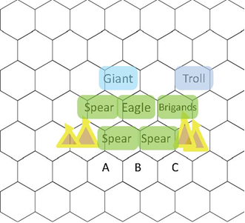

The Giant inflicts hits on the Spearmen forcing them to retreat but they are unable to as they cannot pass through either the friendly spear behind them or the impassible hills. They will take another hit.

If the Spearmen had been Peltasts and thus Light by attribute they could have retreated through the friendly Spearmen behind to A or B

Were the Giant to attack the Eagle it could use Flight to retreat to the hexes A, B or C beyond the friendly Spearmen.

If the Troll defeats the Brigands they can retreat through the spear behind as the have Skirmish as an Attribute allowing them to pass through other friendly units to hexes B or C

Trolls, Giants, or any other massive creature by attribute, can retreat through any other non massive troops or terrain not defined as impassible.

**3.7.3 Evade**. A unit with the Evade skill may retreat 1 or 2 hexes (declare distance before dice rolls) when attacked in Close combat and is attacked as disadvantaged. If evading it cannot choose the Last Gasp fight back option. It may not evade further than it’s first move action in points. It cannot evade off the table and therefore cannot choose evade in this situation and will take an extra damage.

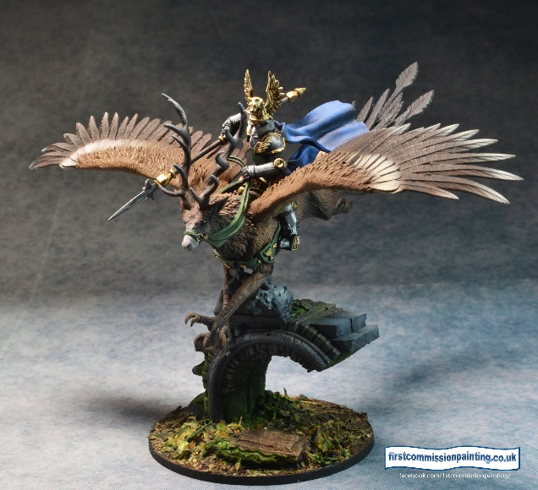

**4.0 Combat**

4.1 Units must be in base contact along an allowed hexside for melee or in range and LoS for shooting.

**4.2 Order of combat**

4.2.1 Attacker declares target of attack and the Defender declares whether he will Defend, Evade (3.7.3 ) or Last Gasp Fight Back (4.4)

4.2.2 Attacker rolls X dice according to his base attacks characteristic plus any bonuses, 4-6 are hits. Natural 6s count as 2 hits. (units with critical hit also count 5s as 2 hits)

4.2.3 Defender rolls X dice according to his base characteristics plus any bonuses, 4-6 are blocks each cancelling a point of damage.

4.2.3 Attacker rolls any built in rerolls and card use rerolls **then** the defender declares any defence rerolls by card use or Brace.

4.2.4 If the attacker achieves more hits than the defender blocks, the difference is the number of hits inflicted on the defender. The defender then retreats 1 space unless steadfast. If no hits get through no retreat is necessary (exception Unstoppable Attribute)

4.2.5 Triggers requiring damage (eg poison) must inflict at least one hit *after blocks* to have effect.

4.2.6 Retreat. A unit which suffers hits must retreat 1 hex away from the attacker, retreating unit’s choice of hex. If it cannot retreat it takes an extra hit per hex unable to retreat.

Some units may be steadfast and ignore retreat. Heroes may discard a black card to do so. Units with flight, massive or skirmish can retreat through any units, those with light through friendly units only and appear directly behind a unit retreated through. (3.7.2)

4.2,7 **Shooting**

Shooting units must be within range, LoS and not adjacent to an enemy unit. Units with a shooting factor may use this against an enemy unit moving into combat with itself as its Last Gasp Fight Back but firing disadvantaged.

Shooting units which move shoot as disadvantaged. Trebuchets, catapults, ballistae, catapults etc may not move and fire in the same turn. Units with Hit and Run Attribute exempt

**4.3 Disadvantage**

When attacking, units may sometimes be disadvantaged by terrain, spell effects or by an attribute of the defender such as evade. Disadvantage means that attacks or defence only succeed on a 5 or 6. Where there are more than one cause of disadvantage hits are only successes on a 6. Defenders rolling against missile attacks are NOT disadvantaged.

4.4 **Last Gasp Fight Back**

**Fight Back Rule** – at the start of combat before ANY dice rolls the defender may declare fight back and use his successful blocks on his defence dice rolls as attacks on the attacker instead of blocks on attackers’ hits. Effectively trading survival for damage to the attacking unit. Support attribute is in effect.

Units with the Volley Fire Attribute may use the last gasp fight back rule using their missile attack value instead of their melee ‘Attack’ value if they were not in contact with any attacker at the start of the attackers move. Such use counts as disadvantaged.

**Extended Example.**

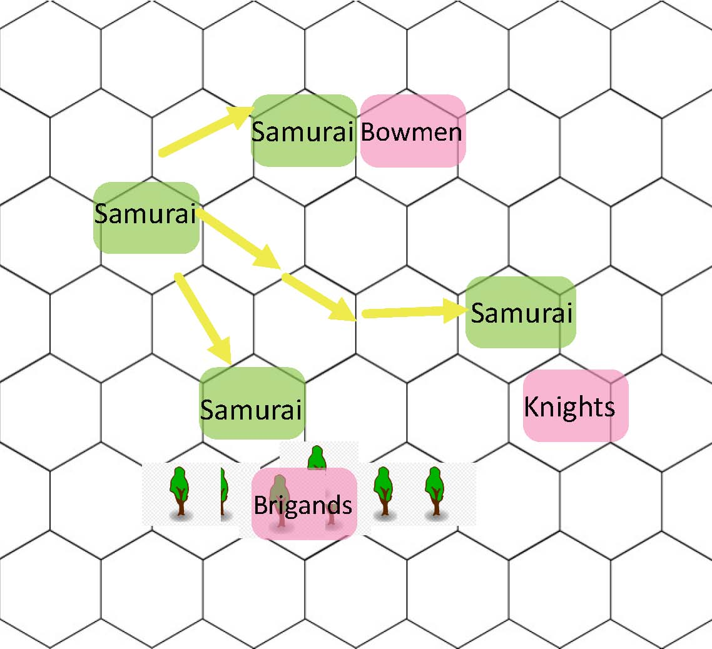

Option One sees the Samurai unit attack the Bowmen unit who are unsupported in the open. The Bowmen can foresee their likely demise and decide to ‘fight back’ rather than trying to defend normally with their 2 dice defence value.

The Samurai unit rolls 4 dice getting 1,4,5 and 6, using the Skilled Attribute he rerolls the 1 getting a 4. This is 5 hits in total as the 6 counts as 2 hits. The Bowmen who have the Attribute Volley Fire roll their 4 missile attack dice as an disadvantaged attack achieving a 3,3,4 and 5. They die but inflict 1 damage on the Samurai unit.

Option Two the Samurai unit instead decides to attack the Knights. The Knights have 4 defence dice and are a much tougher proposition, they decide to defend. The Samurai roll the same dice as previously and the Knights respond with 4 defence dice 1,1,3 and 3 which is very poor and results in no defence. Luckily they have the Attribute Brace 1 allowing them to reroll the 1s. reroll on defence and a black ace in hand allowing them to reroll 3 dice in total. They now roll 4,5,5 which means they take 2 damage. If they have the Attribute Steadfast they can choose not to retreat otherwise they retreat 1 hex.

Option 3 has the Samurai attacking the Brigand unit in the woods. The Samurai are disadvantaged as they don’t have the Attribute Light and are attacking a unit in the woods. This means they hit only on a 5 or 6.

The Brigands do have the Attribute Skirmish so would defend normally on 4 to 6. However they also have the Attribute Evade (3.7.3) and choose to retreat creating a double disadvantage so they are hit only on a 6

This makes the attack disadvantaged meaning only 5s and 6s count as hits. With the same rolls as above the Samurai 6 gets them 2 hits on the Brigands who can Evade up to 2 hexes away. The Brigands roll 3 defence dice gaining 3, 4 and 5 so take 2 hits. The Samurai may follow up one hex.

In any of the combats a Face card would allow a unit to reroll any number of Knights had rolled 2,2,3,3 instead of using a black 2 to reroll just 2 dice they could have use a 6 to 10 black to reroll ALL of the dice.

If it was the Knight unit’s activation and they had moved to attack the Samurai they would receive an extra attack dice for the Attribute Charge +1 and also attack as Advantaged due to having the Attribute Impact.

If it had been the Bowmen unit’s activation they could have used the Volley Fire Attribute offensively to not move but fire as advantaged against the samurai thus hitting on 3 to 6.

4.5 **Two SMU** in the same hex situation – either can be targeted/affected separately with no combat effect on the other. They cannot fight or move together unless one has the follow me rule. If an enemy follows up into the hex after a combat against either SMU then they both retreat into the same hex where possible (3.4).

4.6 **Two hex units** – always fight from the front hex but can be attacked in either. Retreat is away from the attacker whichever hex is attacked. The part of the unit in the attacked hex must follow standard rules for retreat. This may be achieved by pivoting in some circumstance but if not the whole unit must move.

**Combat sequence summary**

Attacker declares attack – defender declares using DF dice to defend or as fight back dice, or to evade (if has Evade attribute) Attacker and defender both roll their dice

Attacker declares any inbuilt rerolls eg Skilled or Frenzy Attacker plays red reroll cards and rerolls all valid dice (can’t reroll a reroll) at the same time

Defender declares built in reroll eg Brace then plays black defence reroll cards and rerolls all valid dice at the same time

NO DIE/DICE CAN BE REROLLED MORE THAN ONCE FOR ANY REASON If an attack causes more hits than defender blocks the difference is damage on the defender who must retreat unless Steadfast or Massive.

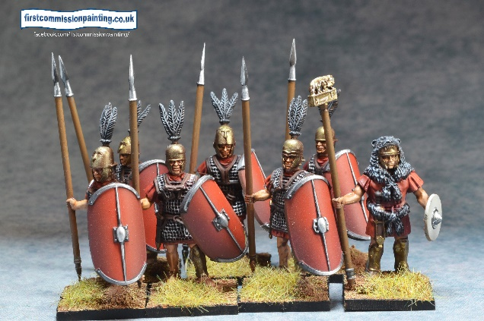Attacker may follow up. Unstoppable must follow up.

**5.0 Willpower**

Willpower represents a unit’s psychology encompassing basic intelligence, willpower and morale.

5.1 When a unit needs to pass a WP test, for example terror, spell resistance etc. It rolls xd6 where x is the WP number of the unit. As with defence rolls each 4, 5 or 6 is equal to a pass. Rerolls require a Black card.

5.2 Terrifying 1/2 – when seeking to attack or defend against a unit with the Terrifying Attribute unit or against the Terrorise spell, the unit must use its willpower roll to pass either Terrifying 1 -requiring 1 pass or Terrifying 2 - requirinq 2 passes. Failure results in fighting as disadvantaged.

5.3 Steadfast = Auto passes terror 1 but requires 1 pass for Terror 2 tests

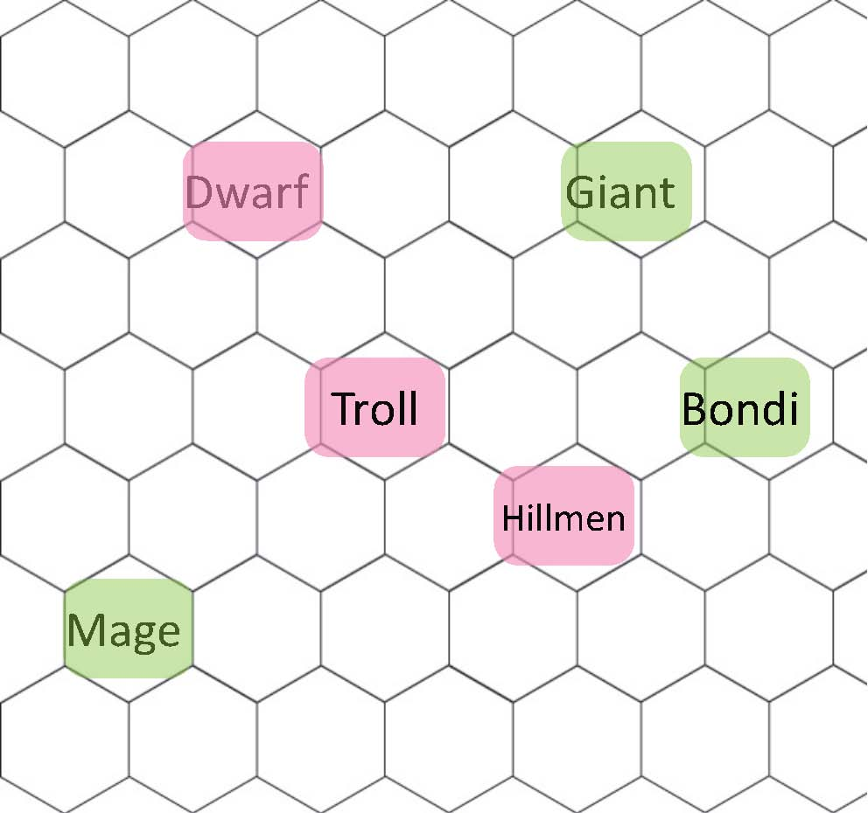

The Mage is considering a Terrorise spell against 3 opponents. Against the Dwarfs he would roll his 4 dice for being Magician 4 but the Dwarfs would roll 5 dice as they are WP 5. This is likely to fail.

The Troll is a better target as it has only WP 2 and should easily be ensorcelled. The Hillmen are also a better target. The Hillmen are also a bit weak willed on a 2 like the troll. As with normal combat a 6 counts as two successes.

**Attacking Terrifying units** - The Giant is the possible target of 3 attacking units. The Dwarfs with 5 WP are likely to pass needing 2 passes on 5 dice so would be a good call to attack the Giant.

The Troll need not roll as it has the Attribute fearless despite being WP2 so could pile in regardless.

The Hillmen will probably fail their Terror 2 test as their WP is 2. An effective attack with them is unlikely to go ahead as discretion becomes the greater part of valour.

The Bondi in their activation could conceivably attack the Troll needing one success from their WP 3 as the Troll is Terror 1.

Alternatively they could attack the Hillmen without a test though they would inevitably Evade (3.7.3) leaving the Bondi disadvantaged and needing 5 or 6 to hit.

Finally they could attack the Dwarfs who would stand to fight and but even if defeated would not retreat as they are Steadfast.

**6.0 Magic users and spells**

6.1 Magic users (Magicians) have a casting ‘Hit number’ which they use as ‘attack dice’ to cast spells based on their WP. EG The Amerindian Medicine Man has Magician 5 He therefore rolls 5 dice on his casts looking for 4-6s for success. Most armies have access to a “Totem” or “Altar” which acts to focus magic allowing Magicians to reroll failed dice if adjacent to the totem or altar.

6.2 If the spell is cast at enemy the target rolls its WP dice as defence dice as per combat to try and negate the spell if they choose to resist. Some spells have no resist number and go through if successfully cast. If the a􀀶acker’s successes outmatch the defenders the spell has succeeded.

6.2.1 Spells cast on friendly units have can choose to have no defence WP roll and go through as long as the magician scores 1 success after making a successful roll to cast.

6.3 All magicians have access to all spells in the spell chart (6.7) that are not limited to specific magic users or magical creatures as noted (6.8) They choose their spells in the pregame phase up to their Magician number. E.G. The Medicine man as a Magician 5 can choose 5 spells for the battle. These can be used more than once in the battle but may have some limitations per activation.

6.4 Some units are not Magicians but have specific spells in their Attributes. These will have the name of the spell plus a number of dice eg. Compel 4. This requires an action to use and the unit simply rolls 4 dice to try and succeed against the opponents defence if necessary.

6.5 Some units have Magic Resistance (MR) which adds a value to the Resist dice Roll eg +1

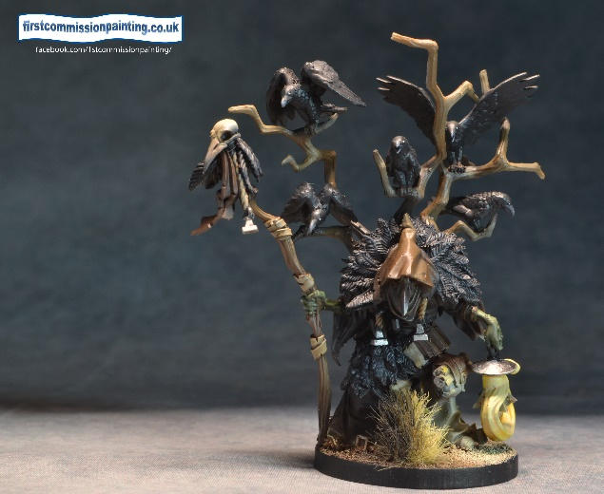6.6 Area spells such as Fog require the target hex to be within range and no affected hex more than 1 hex beyond that.

**6.7 Spell chart**

Spells have a range in hexes and need line of sight. Effects as per the spells table. Users have access to all spells except those in Italics which are specific to certain named users, eg necromancer, medusa, etc (6.8)

**Examples**

An Amerindian Shaman (Magician 4) wants to cast Heal on a damaged friendly unit. The unit is within casting range (4 Hexes) . The Shaman rolls four dice requiring a hit to succeed. He gets the required hit then rolls a 1, 1 and 4. Disappointed he uses a red 3 to reroll all 3 dice gambling that he can do no worse than one heal.

A set of Greek priestesses (Magician 4) see a Troll almost upon them and decides to try and Confuse it They are standing next to the Oracle stone so reroll failed dice. Having successfully rolled to cast needing only one pass on 4 dice they roll for effect getting 3,4,5,6 resulting in 4 hits. The Troll rolls its 2 dice and gets 2 blocks. This leaves two hits to get through and the Troll is Confused 2 meaning its attack dice and defence dice are reduced by two until the end of its next activation.

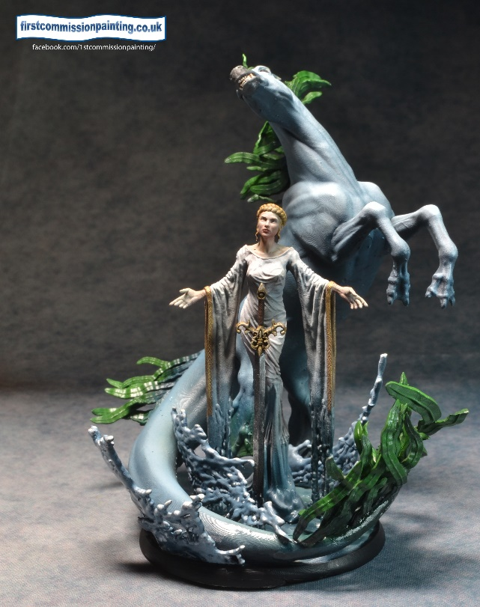

**6.8 Limited spells**

**Summons – summoner declares the creature to be summoned and the number of successes required then rolls magician (x) dice. Always requires 1 rolled success.**

**Raise dead only available to Necromancers**

**Shapeshift available only to specified shapeshifters**

**Fireball only available to specific beasts/users at range & strength x specified**

**All defender tests against WP except where specified eg Fireball & Missile**

|  |  |  |
| --- | --- | --- |
| spell name | Range | Effects and Timing |
| Barrier | 4 | Creates a 3 hex dangerous terrain barrier, thorns, swamp, flames etc. Blocks Los and +2 movement to enter. Cannot be placed on or within 1 hex of a target hex |
| Blinding light | 4 | Target Unit and 2 adjacent units, disadvantaged attacks and defence (end of turn removal) |
| Cleanse or Dispel | 4 | Remove all spell effects/conditions on target unit (immediate effect) or removes effects of area spells eg barrier, fog, burning terrain |
| Compel | 4 | unit attacks adjacent enemy target chosen by magic user if fails WP duel (no special actions or rerolls) |
| Confuse | 4 | unit -1 attack & df dice per unblocked hit max -3 (removed at end of target unit’s next activation) |
| Doom | 4 | target unit rerolls any successful hits or blocks (removed at end of target unit’s next activation) each success affects an adjacent unit of same type |
| Drain Courage | 4 | Unit becomes Dubious until it spends an action to recover by testing against its WP, each success affects an adjacent unit of same type |
| Exorcise | 4 | Summoned / undead units targeted are now subject to critical hit Summoned / Undead. Each success affects an adjacent unit of same type |
| Fireball | 4 | **once per activation** – x attacks against DF andsuccessful hits causes burning 2 and sets fire to burnable terrain (immediate) |
| Fog | 4 | Create a 3 hex fogbank in 3 hexes adjacent to eachother, blocks Los through, disadvantaged into and from within (immediate, removed at end of turn) |
| Fury | 4 | Unit(s) becomes Frenzied and impetuous (until after it fights a melee) each success affects an adjacent unit of same type |
| Hasten | 4 | Unit gains extra move action (immediate) each success moves an adjacent unit of same type |
| Heal | 4 | Heal is number of successful ‘hits’ to a maximum of 3, once per target unit per magician per activation (immediate) |
| Hide | 4 | Hides a unit as per attribute. Each success affects an adjacent unit of same type |
| Immobilise | 4 | Opposed duel, target immobilised unable to move or attack. Defends disadvantaged. (Immediate and requires a face card to activate when condition removed) |
| Inspire | 4 | Unit rerolls 1s and 2s , may inspire adjacent same type troops per success (max 3) (remove on use for next die roll) |
| Lure | 4 | unit moves towards magician its full 1st action allowance if fails (immediate) |
| Missile | 4 | Target unit attacked against DF with a (x)dice where x equals magician number. Critical v all. |
| Raise Dead | 4 | **Target returns as zombie ‘raised unit’ all stats at -1 to normal. No previous attributes remain except flight. Crumbles if killed again or controller killed. Once per activation. (Immediate)** |
| Shapeshift | 4 | Declare form before rolling for success (immediate) |
| Shield | 4 | Unit gains Brace 2 (removed after use) |
| Slow | 4 | unit loses 1 action, mark with slow (removed at end of unit’s next activation) |
| Summon | 4 | Declare the type of summons then Successes on Magician (x) roll equal or greater than the declared target number. (see below) summoned unit has slow (immediate). One successful summon spell per activation allowed per magician unless specified otherwise. If successes are sufficient then more than one of the summoned item may be called. Eg 4 successes would call 2 skeletons. |
| Terrorise | 4 | Opposed duel – If Target loses it **retreats** (3.7.2) full first move (immediate) and becomes Dubious - each success affects an adjacent unit of same type. |
| Terraform | 4 | Create or remove a hex of terrain (woods/marsh/hill/gentle rise). Units on or within are undamaged. Each success affects an adjacent same type hex. (druidic only) |

**7.0 Points, Terrain choice, Objectives, Deployment, Plots and Tacticals**

After Terrain Layout **7.1** but before initiative and deployment roll a d6 for the game’s **objective** – There are 6 possibles and they are scored every turn. Deployment type is also rolled for at this point using a D6 as described in Deployment below

**Objective control** - Control requires more units on / adjacent to the objective than the enemy.

**Plots** – draw 5 cards at start of game before initiative and deployment, you draw 1 new card at start of each turn. You may choose either to score the plot, take advantage of the tactical, or use it as an activation card for any unit if it it is impossible to achieve eg ‘kill a hero’ if there are no enemy heroes.. The card is discarded when either option is used. ***All units count for plot control.***

**7.0.1 Kill points** – VP are gained for each enemy VP killed as listed by unit.

**7.1 Terrain Layout**

Each Army has an Expansion number reflecting it’s historical expansionist tendencies from 1 to 5. Each side rolls d6 and adds its Expansion number. The side with the lower total is the Home Player, the higher is the away player.

The Home player draws 10 cards and uses his Home Terrain table (found with his Army List) to lay out a minimum of 35 and a maximum of 70 hexes of terrain using the table. Each quarter must have at least 12 hexes of terrain. NB an open area chosen by a player from his list counts as terrain

Royals allow choice of any terrain. If a terrain maximum is reached treat the card as nearest number of the players choice.

Where the same number exists for two items the player may choose.

Each player also places a 3 hex camp not on his base edge. Each hex can be looted once for 3 VP by an enemy who controls that hex.

**7.2 Objectives (see map )**

1. **Capture the Relics** – 3 objective markers are placed equidistant along the centre hex row, one in the centre hex, control of objectives gains 5 points for each at end of turn

2. **Domination** – in the central hex and the centre of each quarter is an objective marker. Control of markers at end of turn gains 3 points for each marker in opponents half of board controlled at end of turn. Centre hex is in both sides of the board.

3. **Line breaker** – each player places 3 objective markers at least 4 hexes from each other in the enemy deployment area not on the enemy back row. Score 5 points for each enemy deployment area objective hex controlled at the end of the turn. *Remove the objective once scored*

4. **Rescue** – 5 markers placed on the centre row secretly marked 4,4,3,3,2. Control of a marker reveals score to controller and scores the number of points if controlled at end of turn. *Controller may move the marker with it 1st action move speed. Scores double in own deployment zone?.*

5. **Invasion** – points are gained at end of turn for each unit fully inside the enemy half of the table. Centre row is in both halves. A unit in the enemy half gains 1 point while a unit in the enemy deployment zone is worth 2 points (see 7.1.1 below)

6. **Slaughter** – gain full VP points from enemy units killed in the opponents table half only and half VP FRU elsewhere.

7.2.1 Objective marker control remains with last person to control even if move away unless opponent takes control

**7.3 Deployment** - Deployment Type is rolled for at the same time as Objective (7.0) using the following D6 results

1 - 3 Standard

4 Vertical

5 Diagonal

6 Quartered

During Deployment no unit may be on or beyond the half way hexline for any reason other than Ambush. Army special rules allowing extra forward deployment do not allow deployment in or beyond the hallway hexline. In non standard deployment the longer edge is your baseline.

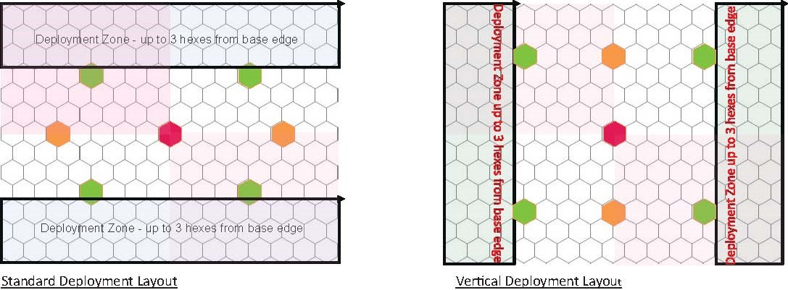

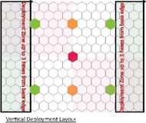

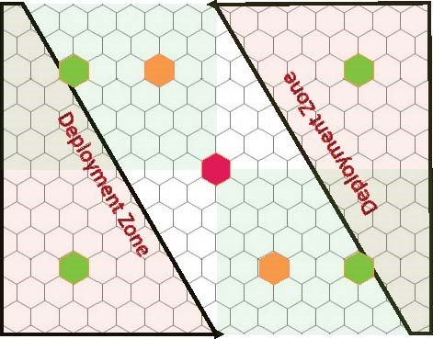

Diagonal Deployment

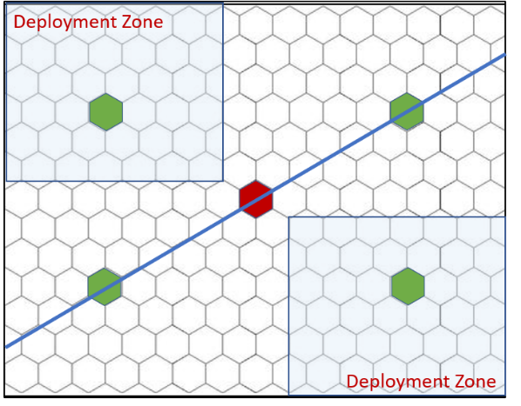

Quartered Deployment

**Hex Key**

Central Hex

Centre Line Hex

Quarter hex

**7.4 Plot cards**

**Cards are played and points are scored at the point they are achieved. Only 1 card of same wording can be scored per round.**

1. Headhunter – kill enemy leader, 2 points (2)

3. Flank Raid – control one mid point flank hex 1 point (4)

4. Encirclement – control both midpoint flank hexes 2 points (2)

5. Mark territory – Have 2 markers down enemy table half not within 4 hexes of each other. 1 points (2)

6. Deep raid – kill a unit in enemy deployment area 1 point (2)

Forwards – have more units in the enemy table half than they have in yours – 1 point (2)

12. Kill most points – kill more points than opponent this turn 1 points (2)

13. Kill more – kill more units than enemy this turn 1 point (4)

15. Assassinate – kill an enemy hero. 1 point if up to 25 points, 2 points if over 25 Vp (4)

16. Bounty – kill an an enemy beast. 1 point if up to 25 points, 2 points if over 25 Vp (4)

**Last Gasp** – kill an enemy unit by last Gasp Fight back combat – 1 point (2)

17. Hold the centre – control centre hex 1 point (4)

18. Kill 2 enemy units this turn 1 points (4)

19. Whizz bang – succeed with two spells (against enemy) in one turn (1)

point(2)

Lead by Example – hero kills enemy worth 20 points or more – 1 point (2)

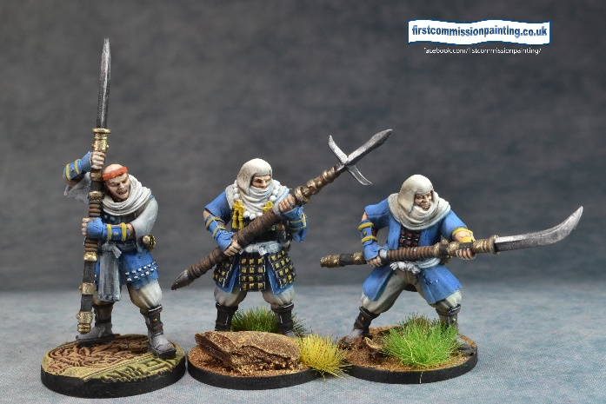40 cards

**7.5 Tactical deck**

**Play at start of a unit activation unless *otherwise stated in Italics***

1. Darken the sky – fire a second time as disadvantaged in one turn if unit did not move (2)

2. Caltrops – *enemy movement -* cavalry or beast attacking the defender is disadvantaged (2)

3. Conch – immediately activate a second unit *after end of friendly activation* ( cancelled by enemy conch) (2)

4. Hold the line - Troops only – *reroll phase* - reroll all/any defence dice v melee attack (2)

5. Shields up – Troops only – *reroll phase* reroll all/any defence dice v missile fire attack (2)

6. Seize initiative – *start of turn* take initiative if lost roll, cancelled by enemy take initiative(2)

7. Recover – heal 2 points (4)

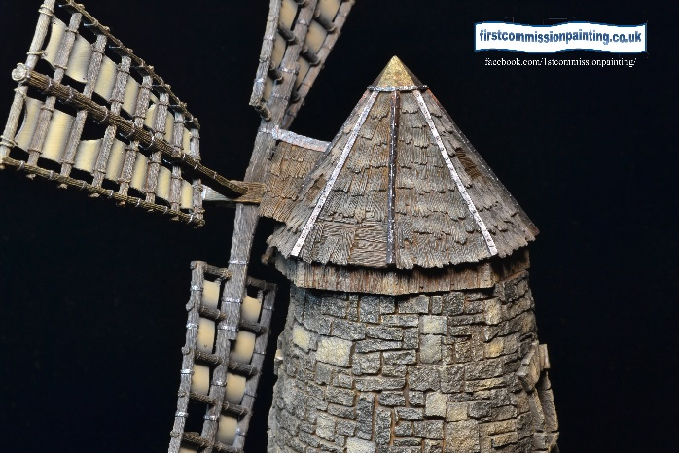8. Surprise attack – *enemy movement* roll 1 attack die against enemy that moves adjacent (2)

9. Parthian cut – *enemy movement* roll 1 attack die against enemy that moves away from adjacent hex (2)

10. Self control – remove 1 condition ie poison, slow, etc (2)

11. All attack – a group with the advance special rule may All move one extra movement point. (2)

12. Hidden enemy – remove 1 random card from enemy hand (2)

13. Unseen path – group of 3 identical unit may move on advance through terrain as if open ground (except river/lake) (2)

14. Whizz – a magician may reroll any failures during the casting of any spell (2)

15. Wrath – enemy unit successfully attacked in melee is made ‘Slow’ (2)

16. Arrowstorm – unit successfully attacked by missile fire is staggered(2)

17. Cancel – *after enemy play of tactical card* cancels any enemy tactical card (2)

18. Desperate defence – *after combat* cancel one enemy hit. (2)

19. Wet weather – *start of turn* – all missile fire disadvantaged (2)

(numbers in brackets are number of that tactical card in the deck.)

**8.0 Terrain**

Default terrain is open. Flyers ignore movement restrictions and zones of control. Combat Effects apply into and out of terrain unless specified.

Burnable terrain in Red – any ‘burning’ attack is defended as DF2. If a damage is caused it then becomes impassible los blocking terrain. Any unit therein must exit 1 hex immediately.

|  |  |  |  |  |  |
| --- | --- | --- | --- | --- | --- |
| Type | Line of sight | Size in hexes Max | Movement cost | Combat effect | Miscellaneous |
| Woods* | blocks | 5 | +1 per Hex unless Light/skirmish | Disadvantaged unless skirmish | No charge/impact bonus |
| Dense woods*/ Jungle | blocks | 4 | +2 per hex  +1 Light/skirmish or Jungle | Disadvantaged unless skirmish, **all** missile disadvantaged | No charge/impact |
| Rough / Brush* | Across 1 hex | 4 | +1 per Hex unless Light/skirmish | Disadvantaged unless skirmish | No charge/impact bonus except Massive |
| Gentle rise | Blocks |  | none | none | none |
| Hills | Blocks |  | none | Disadvantaged fighting uphill except Missile | Disadvantaged fighting uphill bonus uphill |
| Steep hills | blocks |  | +1 per Hex | Disadvantaged fighting uphill | Disadvantaged fighting uphill |
| Village*/ Ruins | Blocks | 4 | +1 per Hex unless Light/skirmish  +2 per hex mounted | Disadvantaged unless skirmish, all missile disadvantaged unless skirmish | No charge/impact bonus |
| Orchards* | Across 1 hex | 4 | +1 mounted | Mounted disadvantaged | No charge/impact bonus |
| Stream | No effect |  | +1 per Hex unless Light/skirmish  Amphibious no extra cost | Disadvantaged within stream unless light, skirmish or amphibious | No charge/impact bonus |
| River / lake | No effect |  | Amphibious/ Flyer only | Amphibious/Flyer only | Blocks Retreat/Evade |
| Marshy* | Across 1 hex | 5 | +2 per hex/ +1 lights/skirmish  Amphibious no extra cost | Disadvantaged unless amphibious | No charge / impact bonus |
| Impassable hill | Blocks | 3 | Impassable / flying ignore | Flyer only | Blocks Retreat/Evade |
| Soft sand / Beach | No effect | 4 | +1 per Hex unless Desert |  | No charge/impact bonus |
| Sand dunes | Blocks | 5 | +1 per Hex unless ‘Desert’ | Disadvantaged unless light, skirmish or ‘Desert trained’ | No charge/impact bonus |
| Gully /Wadi* | No effect across* | 5 | +1 per Hex into and out of unless Light/skirmish | Disadvantaged unless skirmish | No charge/impact bonus * units within can be seen from adjacent or higher hex or adjacent. |
| Oasis* | Blocks except across water | 5 | No move across water unless amphibian. +1 per Hex unless Light/skirmish otherwise | Amphibious/flyer only on water. Missile fire disadvantaged unless light or skirmish | No charge/impact bonus. Water blocks retreat Must have 1 hex water |
| Fields / walls /Gardens/ fences* | Across 1 hex | 4 | +1 per Hex unless Light/skirmish | Disadvantaged attack unless skirmish | No charge/impact  bonus. Missile shot  from hex unaffected |
| Fog / Smoke | See Fog Spell | 4 | +1 stacking | Disadvantaged all - stacks | No charge/impact bonus or missile fire |
| Rocky* | Across 1 hex | 5 | +1 per Hex unless Light/skirmish | Disadvantaged unless skirmish | No charge/impact bonus |
| Bamboo Grove* | Blocks | 3 | +3 all except skirmish +2 | Hits on 6 only, skirmish on 5-6. | No charge/impact |
| Paddy field | No effect | 5 | +1 per Hex unless Light/skirmish or amphibious | Disadvantaged unless skirmish or amphibious | No charge/impact bonus |
| Shrine | No effect | 3 |  |  | Home player gains brace 1 in shrine and no retreat |
| Thorn/Cactus* | Across 1 hex | 5 | +2 per hex unless massive or skirmish | Disadvantaged unless massive | No charge/impact bonus Dangerous |
| Deep Snow / Ice | No effect | 5 | +1 per Hex unless Light/skirmish | Disadvantaged unless massive/Flyer | No charge/impact bonus |

Ambush cover*

**LOS Basics**

* A hex containing terrain is filled with the terrain edge to edge. There is no true line of sight. Line of sight is measured from the centre of the viewers hex to the centre of the target hex. If the line crosses blocking terrain LoS is blocked.

* A unit can see into the first hex of all terrain types but no further unless stated as ‘across’ in table 9.0

* Units on hills can see over all terrain except other same level or higher hills. MMUs, Massive, Woods, Village or ruins have 1 blind hex to the viewers LOS from hills. Lower levels of the same hill do not create blind hexes

* Hill levels are abstracted as plateaus. A unit can see all units on the same level. A unit not on the edge hex of a hill cannot see to lower terrain.

* All terrain which blocks line of sight inherently provides blind hexes as per villages,

* Units in gullies can be seen from an adjacent hex or from a hill and vice versa.

* Massive units are visible over non massive but other units block LoS

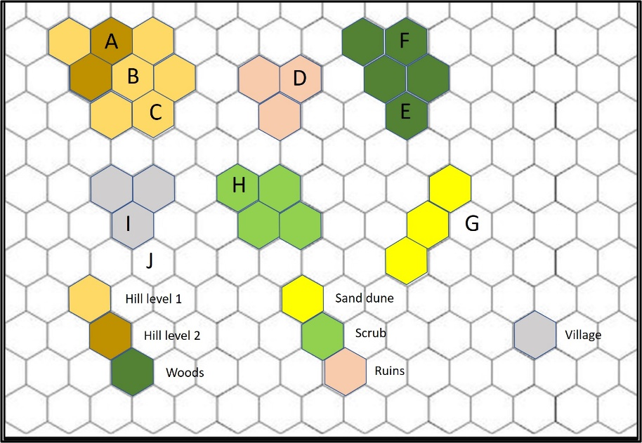

**Line of Sight examples**

A is on an edge hex of a level 2 hill and can see B & C lower on the same hill. It can see most of the terrain beneath. Note that B can see only A and C (plus the other level 1 hill hexes it’s side of the level 2 hill) as it occupies a non edge hill hex.

D is visible as it can see across 1 hex of ruins into the next hex of ruins.

E is visible in the woods as the Los enters the first hex unlike F which cannot be seen by any other unit as it is beyond the first hex.

G is in the one hex blind ‘zone’ behind the los blocking sand dune even though A is higher.

I & J are invisible to A as I is in the second hex of village terrain and J is in the one hex blind zone.

H is clearly visible in the brush/scrub as it is in the first hex of scrub. It would not be visible at the opposite end of the scrub as A could only see across the first hex into the second but not the third.

**Movement Basics**

* Retreats and evades ignore additional movement costs. Flight ignores movement costs

* Any terrain with an additional movement cost is Bad Going.

* Dangerous terrain - units except Skirmish, roll a d6 and on a 6 either take 1 point of damage or stop movement.

**9. Attributes**

|  |  |
| --- | --- |
| Advance | Up to 3 adjacent same name units may activate as one unit. Additionally If activated by a captain they do not have to end adjacent or do the same actions. Additionally they may all use a captains black card move bonus. Units without a captain may not benefit together from a black card movement bonus, only the unit on which played (captain defined as hero with advance) |
| Advance +/- | As above but **Advance +** may activate up to 3 same name units on a 3+.  **Advance –** as above but activates on a 7+ |
| Agile | When defending may choose one of the attackers dice to reroll |
| Altar | Allows rerolls of failed dice to magician / spell caster in contact |
| Ambush | At deployment a unit placed anywhere outside enemy deployment area not next to an enemy unit. Initiative order for alternate placement. If in terrain providing cover to sight it cannot be attacked until “discovered” by enemy spending movement attempting to enter & being returned to previous hex or by ambushing unit activating |
| Amphibious | move/attack through wet stuff unhindered |
| Attachment | Unit may be attached (adjacent hex) to any unit with advance and acts as part of same. It moves with and fights on the parent unit’s advance. It may detach at the start of a turn but not then re-attach. |
| Aura | Unit has permanent aura of effect expressed in los hexes eg aura 2 affects 2 hexes away in los |
| Banner 1 / 2 | reroll 1s/2s to units within 3 hexes & LOS (visible over non massive units) |
| Blast | Unit adjacent to target (Firer’s choice) takes half of initial final damage, FRD |
| Bleed | Enemy discard a card or take 1 extra damage |
| Bodyguard | Can take half the damage inflicted (FRU) on an adjacent smu up to bodyguard units’ HP total |
| Brace 1 / 2 | reroll 1s or 2s defence dice |
| Burning X | target takes 1 burning damage at end of turn - reduces by one each turn |
| Channel X | spells can be cast from this unit by x magician |
| Charge | +1 die on a move to combat, not available if starts adjacent to any enemy or any cause of disadvantage present during the movement or combat. |
| Cleave | Perform a 2nd attack on any valid enemy. No rerolls/bonus to either side |
| Command X | Action to order x friendly unit to perform a move out of it’s activation – LoS within 3 hexes . X= units commanded. Troops and beasts only. |
| Copy | Unit copies attacks and attributes of adjacent enemy |
| Critical Hit X | Hits on 5 count as 2 hits as per a 6 against x target |
| Crush | This unit may **end** its movement on a non massive target. Target unit suffers 1 free crush attack immediately with no defence and retreats as per usual rules after crush. This does not count as the units’ attack. |
| Deadly | Defender disadvantaged on defence (sometimes only on charge) |
| Deep strike flank | Unit may enter on any flank hex at cost of first action. It may use its second movement action only or attack disadvantaged. Must enter by passing a WP test and activating normally by card use. May use Advance. |
| Deep strike cover | Unit enters on any unoccupied hex providing cover outside enemy deployment as per deep strike. May attack as second action but disadvantaged. |
| Deep strike total | Unit enters on any unoccupied hex outside enemy deployment as per deep strike. May attack as second action but disadvantaged. |
| Dubious | fights as disadvantaged and retreats 2 spaces after combat loss per hit point lost. Removed after a successful WP check for 1 action |
| Ethereal | unhindered by terrain or units, attacks against ethereals are disadvantaged. A unit passed through by an ethereal tests Fear 1 and loses 1 damage if fails. Max once per turn per ethereal or per victim |
| Evade | retreat 1 or2 hexes a􀁌er attack declared defenders choice, attacker disadvantaged |
| First strike | Df roll acts as both Df roll and an attack, cannot be used against any subsequent attack eg cleave. Cancelled in bad going. |
| Flight | unhindered by terrain, place unit. Melee attacks against unit disadvantaged if unit not yet activated. |
| Focus fire | Action - Up to 3 adjacent units with Advance attribute may fire as one activation each adding +1 die to the fire of one chosen unit as one action |
| Follow me | Up to 2 adjacent friendly units follow as if on same actions ie move then fight if poss. Must start/end adjacent to the follow me unit. Not an Action. |
| Frenzy | extra attack die on charge, can choose to reroll ALL dice (see impetuous) |
| Hack | a unit which moves out of the zone of control of a faster enemy with the hack attribute immediately takes a single disadvantaged attack from that enemy with no DF roll. One hack per hacker or hackee. |
| Heal | hits restored at range X per success also removes burning/poison |
| Hit & run | move after attack without penalty |
| Hidden | Unit cannot be targeted with missile attacks until it moves or fires or casts spell. Can become hidden as an action |
| Immobilise | target becomes unable to move or attack, defends disadvantaged and requires a face card to activate. |
| Immortal | Heals X hp at activation using a card to activate – 1hp 1-5, 2hp 6-10, 3hp face card. Can use to bring back to life once during game at HP level from card. |
| Impact | Defender is disadvantaged during an attack which fulfils the conditions of Charge by attacker |
| Impetuous | Must move at least 1 hex towards nearest visible enemy at start of turn if possible, reroll attack misses on a move ending in valid combat. Impetuous lost after 1 charge / combat. |
| Knock aside | push a unit out of movement path - same size or smaller. If unit cannot move takes 1 damage and movement stops |
| Light | move through most terrain unhindered, some exceptions |
| Lucky | may remove 1 success dice from enemy attack and reroll with no further rerolls |
| Lure | Wp test on target, failure requires max 1st action move towards caster |
| Magical resistance x | Wp tests to resist spells +1 to dice |
| Magician X | number of dice used to cast spells and number of spells can choose pregame |
| Massed | Advance for up to 6 units of the same type or activated by hero as per advance |
| Massive | los over non massive, can move through enemy control hexes, can choose to ignore retreats except to unstoppable |
| Mob | Advance plus Support on Attack only – up to 6 units |
| No retreat | Unit takes extra damage and does not retreat unless enemy is Unstoppable |
| Poison X | extra 1 damage during the end of each turn until healed / cleansed, reduce by 1 point end turn |
| Ringbearer | ACTION goes invisible, only visible to ethereal, Sauron, gollum and ringwraiths who attack at +1 die. Take 1 damage. |
| Regenerate | heal X hp at start of activation discarding a card as per Heal spell. |
| Fearless | Ignores Terror |
| Scavenger | + 1 attack against wounded enemies |
| Self control | remove one condition at start of activation |
| Self destruct | May choose to self destruct at end of unit’s activation for a cleave attack then removed as casualty vp to enemy |
| Skilled 1-3 | Reroll 1s, 1&2s, 1,2 &3s etc in attacks, or missile attacks |
| Skirmish | move through own units (&V.V) ignore ZoC, fights as normal in disadvantage terrain |
| Slow | enemy unit loses an action unless discards additional card |
| Soul stealer | gains 1 hp for each 2 hp inflicted – can go above starting hp |
| Specialist | Free interact |
| Split attack | May divide attacks amongst valid targets |
| Spy (max 2) | Randomly discard 2 cards from enemy hand (once per activation) enemy redraws 1. |
| Stagger | enemy loses 1 hex of movement per hit unsaved cumulative |
| Steadfast | May ignore retreat after loss in combat (exception v unstoppable) |
| Stealthy | All missile attacks disadvantaged plus light |
| Stun | enemy cannot use cards or attributes until end of its next activation |
| Support | provides a single reroll die in all rolls to an adjacent same name unit with the support attribute. Applies in last gasp rolls. |
| Swoop | after normal successful attack against non massive/flyer single figure unit drop within 2 hexes for an additional d3 damage with no defence - no rerolls |
| Terror 1 / 2 | Causes WP test to attacker or defender requiring 1 or 2 passes, failure causes disadvantage in close combat . |
| Unreliable | Misfires on Two 1s, destroyed on 3 1s, before any rerolls |
| Unstoppable | Follows up and performs 2nd attack on same adjacent target no bonus/rerolls for either side. Counts if enemy failed to retreat eg no retreat |
| Veteran | May discard any card to reroll any number of dice |
|  |  |